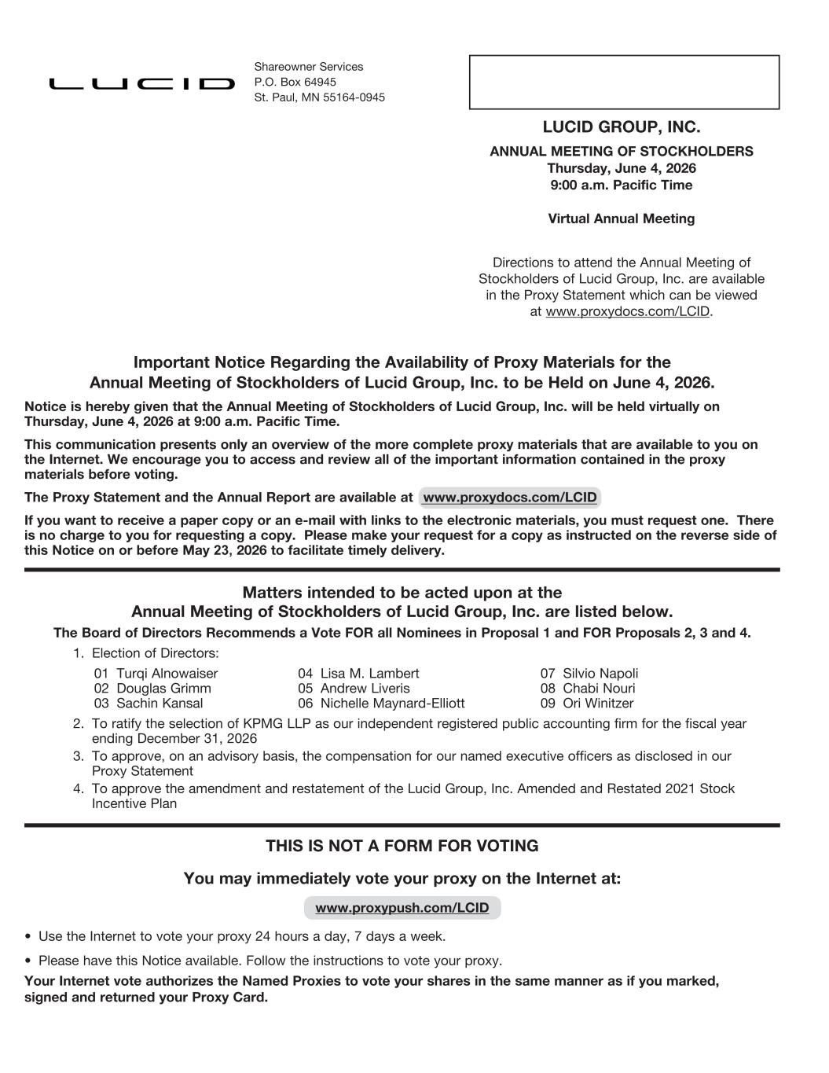
LUCID GROUP, INC. ANNUAL MEETING OF STOCKHOLDERS Thursday, June 4, 2026 9:00 a.m. Pacific Time Virtual Annual Meeting Directions to attend the Annual Meeting of Stockholders of Lucid Group, Inc. are available in the Proxy Statement which can be viewed at www.proxydocs.com/LCID. Important Notice Regarding the Availability of Proxy Materials for the Annual Meeting of Stockholders of Lucid Group, Inc. to be Held on June 4, 2026. Notice is hereby given that the Annual Meeting of Stockholders of Lucid Group, Inc. will be held virtually on Thursday, June 4, 2026 at 9:00 a.m. Pacific Time. This communication presents only an overview of the more complete proxy materials that are available to you on the Internet. We encourage you to access and review all of the important information contained in the proxy materials before voting. The Proxy Statement and the Annual Report are available at www.proxydocs.com/LCID If you want to receive a paper copy or an e-mail with links to the electronic materials, you must request one. There is no charge to you for requesting a copy. Please make your request for a copy as instructed on the reverse side of this Notice on or before May 23, 2026 to facilitate timely delivery. Matters intended to be acted upon at the Annual Meeting of Stockholders of Lucid Group, Inc. are listed below. The Board of Directors Recommends a Vote FOR all Nominees in Proposal 1 and FOR Proposals 2, 3 and 4. 1. Election of Directors: 01 Turqi Alnowaiser 04 Lisa M. Lambert 07 Silvio Napoli 02 Douglas Grimm 05 Andrew Liveris 08 Chabi Nouri 03 Sachin Kansal 06 Nichelle Maynard-Elliott 09 Ori Winitzer 2. To ratify the selection of KPMG LLP as our independent registered public accounting firm for the fiscal year ending December 31, 2026 3. To approve, on an advisory basis, the compensation for our named executive officers as disclosed in our Proxy Statement 4. To approve the amendment and restatement of the Lucid Group, Inc. Amended and Restated 2021 Stock Incentive Plan THIS IS NOT A FORM FOR VOTING You may immediately vote your proxy on the Internet at: www.proxypush.com/LCID • Use the Internet to vote your proxy 24 hours a day, 7 days a week. • Please have this Notice available. Follow the instructions to vote your proxy. Your Internet vote authorizes the Named Proxies to vote your shares in the same manner as if you marked, signed and returned your Proxy Card. Shareowner Services P.O. Box 64945 St. Paul, MN 55164-0945

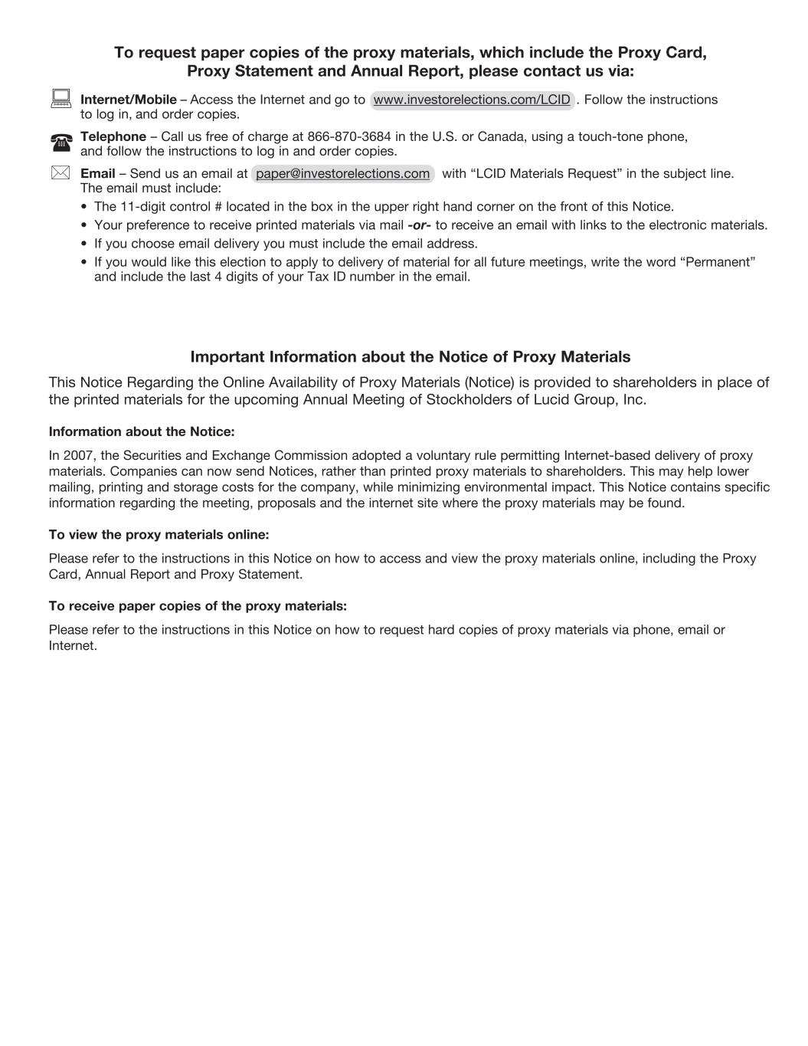
To request paper copies of the proxy materials, which include the Proxy Card, Proxy Statement and Annual Report, please contact us via: : Internet/Mobile – Access the Internet and go to www.investorelections.com/LCID . Follow the instructions to log in, and order copies. ( Telephone – Call us free of charge at 866-870-3684 in the U.S. or Canada, using a touch-tone phone, and follow the instructions to log in and order copies. * Email – Send us an email at paper@investorelections.com with “LCID Materials Request” in the subject line. The email must include: • The 11-digit control # located in the box in the upper right hand corner on the front of this Notice. • Your preference to receive printed materials via mail -or- to receive an email with links to the electronic materials. • If you choose email delivery you must include the email address. • If you would like this election to apply to delivery of material for all future meetings, write the word “Permanent” and include the last 4 digits of your Tax ID number in the email. Important Information about the Notice of Proxy Materials This Notice Regarding the Online Availability of Proxy Materials (Notice) is provided to shareholders in place of the printed materials for the upcoming Annual Meeting of Stockholders of Lucid Group, Inc. Information about the Notice: In 2007, the Securities and Exchange Commission adopted a voluntary rule permitting Internet-based delivery of proxy materials. Companies can now send Notices, rather than printed proxy materials to shareholders. This may help lower mailing, printing and storage costs for the company, while minimizing environmental impact. This Notice contains specific information regarding the meeting, proposals and the internet site where the proxy materials may be found. To view the proxy materials online: Please refer to the instructions in this Notice on how to access and view the proxy materials online, including the Proxy Card, Annual Report and Proxy Statement. To receive paper copies of the proxy materials: Please refer to the instructions in this Notice on how to request hard copies of proxy materials via phone, email or Internet.

