Filed by Churchill Capital Corp IV

pursuant to Rule 425 under the Securities Act of 1933

and deemed filed pursuant to Rule 14a-12

under the Securities Exchange Act of 1934

Subject Company: Churchill Capital Corp IV

Commission File No. 001-39408

The following communications were made available by Lucid Motors on Twitter, Facebook and LinkedIn on July 22, 2021:

Twitter: $CCIV voting extended. ALL stockholders are encouraged to vote regardless of the number of shares held. Shares that are not voted will not be counted as FOR the transaction. Vote now by calling MacKenzie Partners at (800) 322-2885 or +1-212-929-5500.

https://www.prnewswire.com/news-releases/churchill-iv-polls-remain-open-for-business-combination-with-lucid-motors-301339443.html? tc=eml_cleartime

For more information: https://www.sec.gov/Archives/edgar/data/0001811210/000110465921085384/tm219359-12_424b3.htm
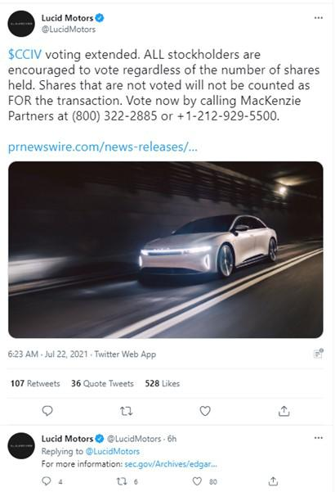

Twitter: Investor call with $CCIV Chairman Michael Klein and Lucid CEO Peter Rawlinson to be held today at 11:30 am EST. Stockholders encouraged to join. Investors can join via webcast or dial in.

Webcast: https://ccmediaframe.com/?id=Pd283Gjl

For more information: https://www.sec.gov/Archives/edgar/data/0001811210/000110465921085384/tm219359-12_424b3.htm
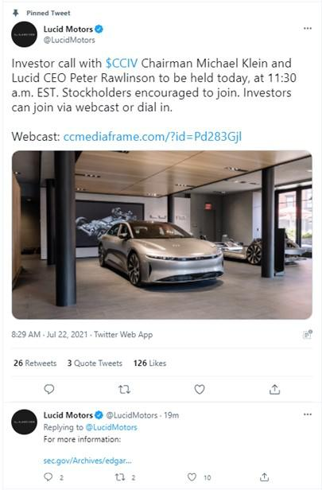

Twitter: ICYMI: Investor call with $CCIV Chairmain Michael Klein and Lucid CEO Peter Rawlinson took plce this morning. Don’t forget to vote today by calling by calling (800) 322-2885 or +1-212-929-5500.

Webcast: http://ccmediaframe.com/?id=Pd283Gjl
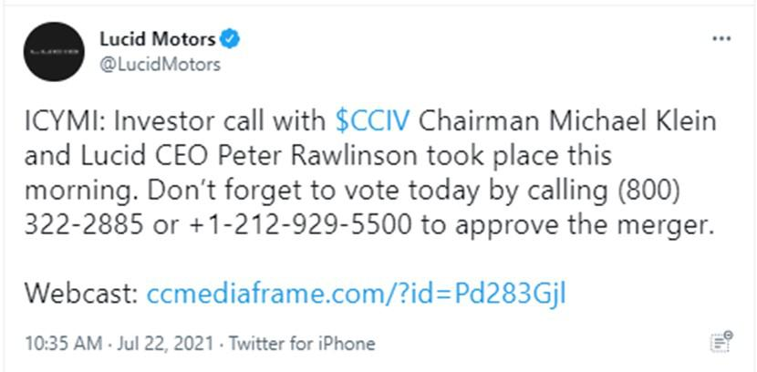

Twitter: $CCIV shareholders should check their spam filters and email for the term “Churchill Capital” to find their voting instructions for the #LucidMotors Transaction. AND then Vote!

https://www.theverge.com/2021/7/22/22588798/lucid-motors-churchill-capital-merger-cciv-lcid-merger-spac-delay

You can vote instantly by contacting MacKenzie Partners, Churcill IV’s proxy solicitor, for help, call toll-free at 1-800-322-2885, internationally at +1-212-929-5500 or online at proxyvote.com or proxypush.com.
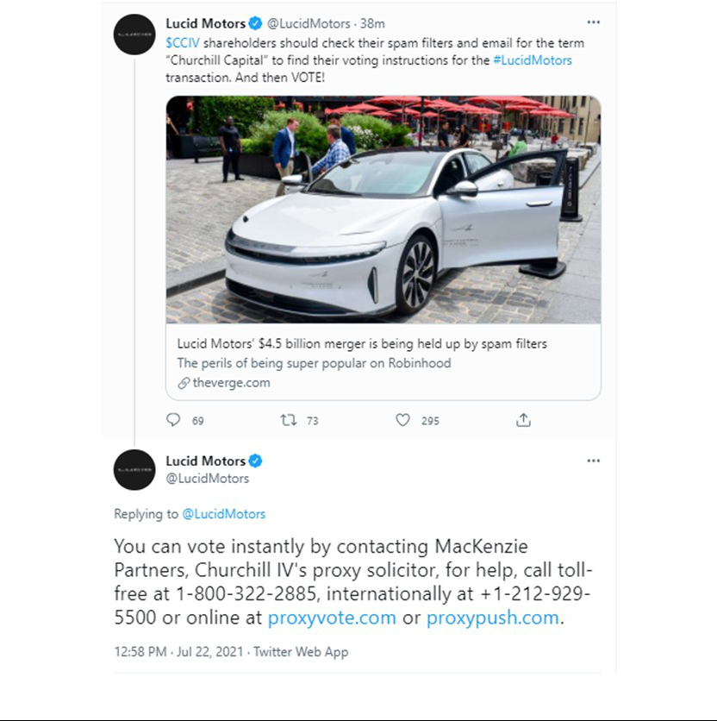

Facebook: Investor call with $CCIV Chairman Michael Klein and Lucid CEO Peter Rawlinson to be held today at 11:30 am EST. Stockholders encouraged to join. Investors can join via webcast or dial in.

Webcast: https://ccmediaframe.com/?id=Pd283Gjl

For more information: https://www.prnewswire.com/news-releases/churchill-capital-corp-iv-chairman-and-ceo-michael-klein-and-lucid-motors-ceo-and-cto-peter-rawlinson-to-host-investor-call-today-at-1130-am-to-discuss-lucid-business-combination-and-importance-of-voting-as-soon-as-possible-301339615.html?tc=eml_cleartime


Facebook: Investor call with $CCIV Chairman Michael Klein and Lucid CEO Peter Rawlinson to be held on Friday, July 23, 2021 at 11:30 am EST.

Stockholders encouraged to join. Investors can join via webcast or dial in.

Webcast: https://ccmediaframe.com/?id=Pd283Gjl


LinkedIn: Investor call with $CCIV Chairman Michael Klein and Lucid CEO Peter Rawlinson to be held today at 11:30 am EST. Stockholders encouraged to join. Investors can join via webcast or dial in.

Webcast: https://lnkd.in/eeiG6vD

For more information: https://www.prnewswire.com/news-releases/churchill-capital-corp-iv-chairman-and-ceo-michael-klein-and-lucid-motors-ceo-and-cto-peter-rawlinson-to-host-investor-call-today-at-1130-am-to-discuss-lucid-business-combination-and-importance-of-voting-as-soon-as-possible-301339615.html?tc=eml_cleartime
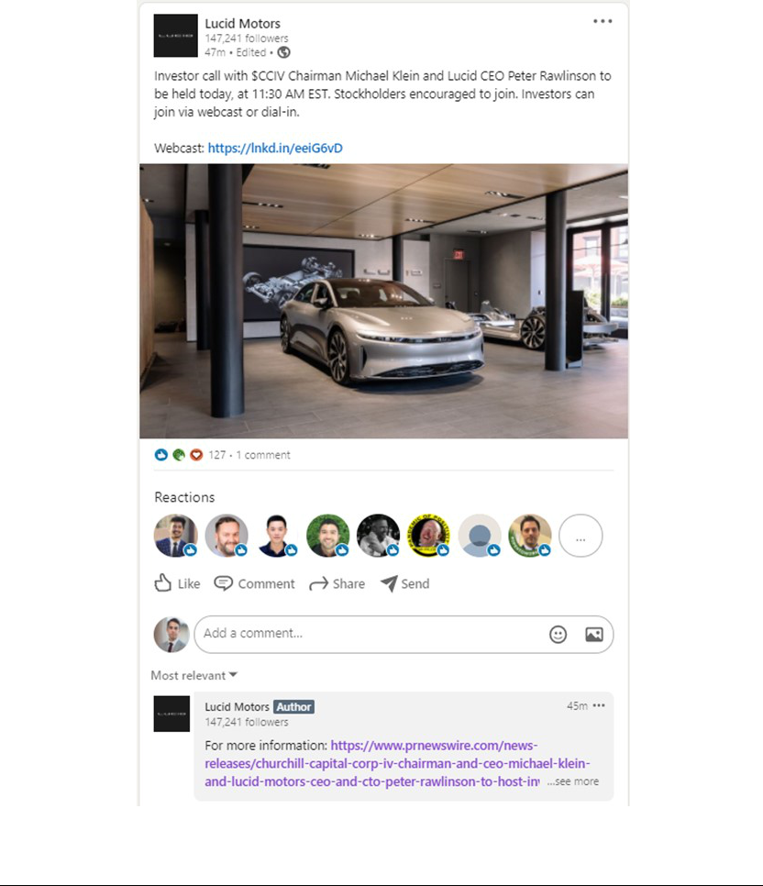

IMPORTANT LEGAL INFORMATION

Additional Information About the Proposed Transactions and Where to Find It

This communication does not constitute an offer to sell or exchange, or the solicitation of an offer to buy or exchange, any securities, nor shall there be any sale of securities in any jurisdiction in which such offer, sale or exchange would be unlawful prior to registration or qualification under the securities laws of any such jurisdiction. In connection with the proposed business combination, Churchill Capital Corp IV (“CCIV”) filed a registration statement on Form S-4, as amended (the “Form S-4”), with the U.S. Securities and Exchange Commission (the “SEC”). The Form S-4 was declared effective June 25, 2021. The Form S-4 includes a document that serves as a prospectus and proxy statement of CCIV, referred to as a proxy statement/prospectus, that is both the proxy statement/prospectus which has been distributed to CCIV’s shareholders in connection with CCIV’s solicitation of proxies for the vote by CCIV’s shareholders with respect to the proposed transaction as described in the Form S-4 as well as the prospectus relating to the proposed business combination as described in the Form S-4. CCIV also will file other documents regarding the proposed business combination with the SEC. Before making any voting decision, investors and security holders of CCIV are urged to read the Form S-4 and all other relevant documents filed or that will be filed with the SEC in connection with the proposed business combination as they become available because they will contain important information about the proposed transaction. CCIV has mailed a definitive proxy statement/prospectus and other relevant documents to its shareholders of record as of June 21, 2021, the record date established for the special meeting of stockholders relating to the proposed business combination. Investors and security holders may obtain free copies of the Form S-4 and all other relevant documents filed or that will be filed with the SEC by CCIV through the website maintained by the SEC at www.sec.gov. The documents filed by CCIV with the SEC also may be obtained free of charge at CCIV’s website at: https://iv.churchillcapitalcorp.com/# or upon written request to 640 Fifth Avenue, 12th Floor New York, NY 10019.

INVESTMENT IN ANY SECURITIES DESCRIBED HEREIN HAS NOT BEEN APPROVED OR DISAPPROVED BY THE SEC OR ANY OTHER REGULATORY AUTHORITY NOR HAS ANY AUTHORITY PASSED UPON OR ENDORSED THE MERITS OF THE OFFERING OR THE ACCURACY OR ADEQUACY OF THE INFORMATION CONTAINED HEREIN. ANY REPRESENTATION TO THE CONTRARY IS A CRIMINAL OFFENSE.

Participants in the Solicitation

CCIV, Lucid and certain of their respective directors, executive officers and other members of management and employees may, under SEC rules, be deemed to be participants in the solicitations of proxies from CCIV’s shareholders in connection with the proposed transactions. Information regarding the persons who may, under SEC rules, be deemed participants in the solicitation of CCIV’s shareholders in connection with the proposed transactions is set forth in CCIV’s proxy statement/prospectus included in the Form S-4. Additional information regarding the participants in the proxy solicitation and a description of their direct and indirect interests is included in the proxy statement/prospectus. Shareholders, potential investors and other interested persons should read the proxy statement/prospectus carefully before making any voting or investment decisions. You may obtain free copies of these documents from the sources indicated above.

No Offer or Solicitation

This communication does not constitute an offer to sell or the solicitation of an offer to buy any securities, or a solicitation of any vote or approval, nor shall there be any sale of securities in any jurisdiction in which such offer, solicitation or sale would be unlawful prior to registration or qualification under the securities laws of any such jurisdiction.

Trademarks

This communication contains trademarks, service marks, trade names and copyrights of Lucid, CCIV and other companies, which are the property of their respective owners.

Forward-Looking Statements

This communication includes “forward-looking statements” within the meaning of the “safe harbor” provisions of the United States Private Securities Litigation Reform Act of 1995. Forward-looking statements may be identified by the use of words such as “estimate,” “plan,” “project,” “forecast,” “intend,” “will,” “expect,” “anticipate,” “believe,” “seek,” “target,” “continue,” “could,” “may,” “might,” “possible,” “potential,” “predict” or other similar expressions that predict or indicate future events or trends or that are not statements of historical matters. These forward-looking statements include, but are not limited to, statements regarding estimates and forecasts of financial and operational metrics, projections of market opportunity, market share and product sales, expectations and timing related to commercial product launches, including the start of production and launch of the Lucid Air and any future products, the performance, range, autonomous driving and other features of the Lucid Air, future market opportunities, including with respect to energy storage systems and automotive partnerships, future manufacturing capabilities and facilities, future sales channels and strategies, future market launches and expansion, potential benefits of the proposed business combination and PIPE investment (collectively, the “proposed transactions”) and the potential success of Lucid’s go-to-market strategy, and expectations related to the terms and timing of the proposed transactions. These statements are based on various assumptions, whether or not identified in this communication, and on the current expectations of Lucid’s and CCIV’s management and are not predictions of actual performance. These forward-looking statements are provided for illustrative purposes only and are not intended to serve as, and must not be relied on by any investor as, a guarantee, an assurance, a prediction or a definitive statement of fact or probability. Actual events and circumstances are difficult or impossible to predict and will differ from assumptions. Many actual events and circumstances are beyond the control of Lucid and CCIV. These forward-looking statements are subject to a number of risks and uncertainties, including changes in domestic and foreign business, market, financial, political and legal conditions; the inability of the parties to successfully or timely consummate the proposed transactions, including the risk that any required regulatory approvals are not obtained, are delayed or are subject to unanticipated conditions that could adversely affect the combined company or the expected benefits of the proposed transactions or that the approval of the shareholders of CCIV or Lucid is not obtained; the outcome of any legal proceedings that may be instituted against Lucid or CCIV following announcement of the proposed transactions; failure to realize the anticipated benefits of the proposed transactions; risks relating to the uncertainty of the projected financial information with respect to Lucid, including conversion of reservations into binding orders; risks related to the timing of expected business milestones and commercial launch, including Lucid’s ability to mass produce the Lucid Air and complete the tooling of its manufacturing facility; risks related to the expansion of Lucid’s manufacturing facility and the increase of Lucid’s production capacity; risks related to future market adoption of Lucid’s offerings; the effects of competition and the pace and depth of electric vehicle adoption generally on Lucid’s future business; changes in regulatory requirements, governmental incentives and fuel and energy prices; Lucid’s ability to rapidly innovate; Lucid’s ability to deliver Environmental Protection Agency (“EPA”) estimated driving ranges that match or exceed its pre-production projected driving ranges; future changes to vehicle specifications which may impact performance, pricing, and other expectations; Lucid’s ability to enter into or maintain partnerships with original equipment manufacturers, vendors and technology providers; Lucid’s ability to effectively manage its growth and recruit and retain key employees, including its chief executive officer and executive team; Lucid’s ability to establish its brand and capture additional market share, and the risks associated with negative press or reputational harm; Lucid’s ability to manage expenses; Lucid’s ability to effectively utilize zero emission vehicle credits; the amount of redemption requests made by CCIV’s public shareholders; the ability of CCIV or the combined company to issue equity or equity-linked securities in connection with the proposed transactions or in the future; the outcome of any potential litigation, government and regulatory proceedings, investigations and inquiries; and the impact of the global COVID-19 pandemic on Lucid, CCIV, the combined company’s projected results of operations, financial performance or other financial metrics, or on any of the foregoing risks; and those factors discussed in the Form S-4, CCIV’s Annual Report on Form 10-K/A for the year ended December 31, 2020 and CCIV’s Quarterly Report on Form 10-Q for the quarter ended March 31, 2021, in each case, under the heading “Risk Factors,” as well as other documents of CCIV filed, or to be filed, with the SEC. If any of these risks materialize or our assumptions prove incorrect, actual results could differ materially from the results implied by these forward-looking statements. There may be additional risks that neither Lucid nor CCIV presently know or that Lucid and CCIV currently believe are immaterial that could also cause actual results to differ from those contained in the forward-looking statements. In addition, forward-looking statements reflect Lucid’s and CCIV’s expectations, plans or forecasts of future events and views as of the date of this communication. Lucid and CCIV anticipate that subsequent events and developments will cause Lucid’s and CCIV’s assessments to change. However, while Lucid and CCIV may elect to update these forward-looking statements at some point in the future, Lucid and CCIV specifically disclaim any obligation to do so. These forward-looking statements should not be relied upon as representing Lucid’s and CCIV’s assessments as of any date subsequent to the date of this communication. Accordingly, undue reliance should not be placed upon the forward-looking statements.

