Filed by Churchill Capital Corp IV

pursuant to Rule 425 under the Securities Act of 1933

and deemed filed pursuant to Rule 14a-12

under the Securities Exchange Act of 1934

Subject Company: Churchill Capital Corp IV

Commission File No. 001-39408

Date: February 25, 2021

The following communication was made available by Lucid Motors on its employee Intranet:
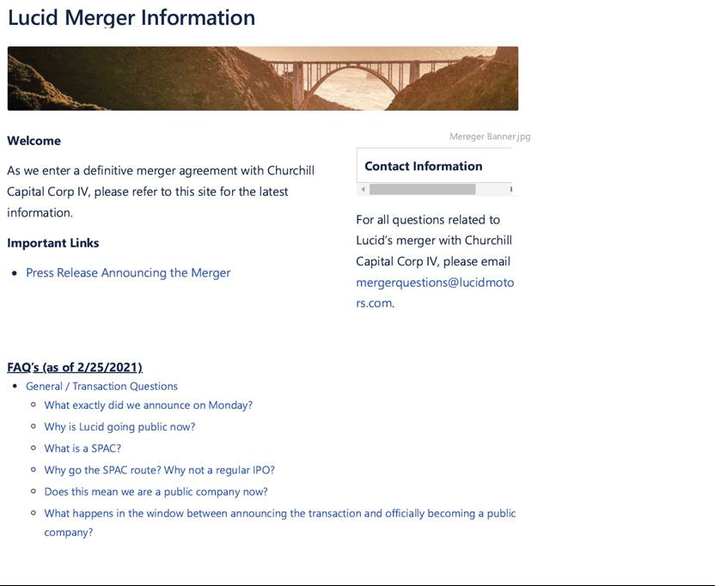



2



3

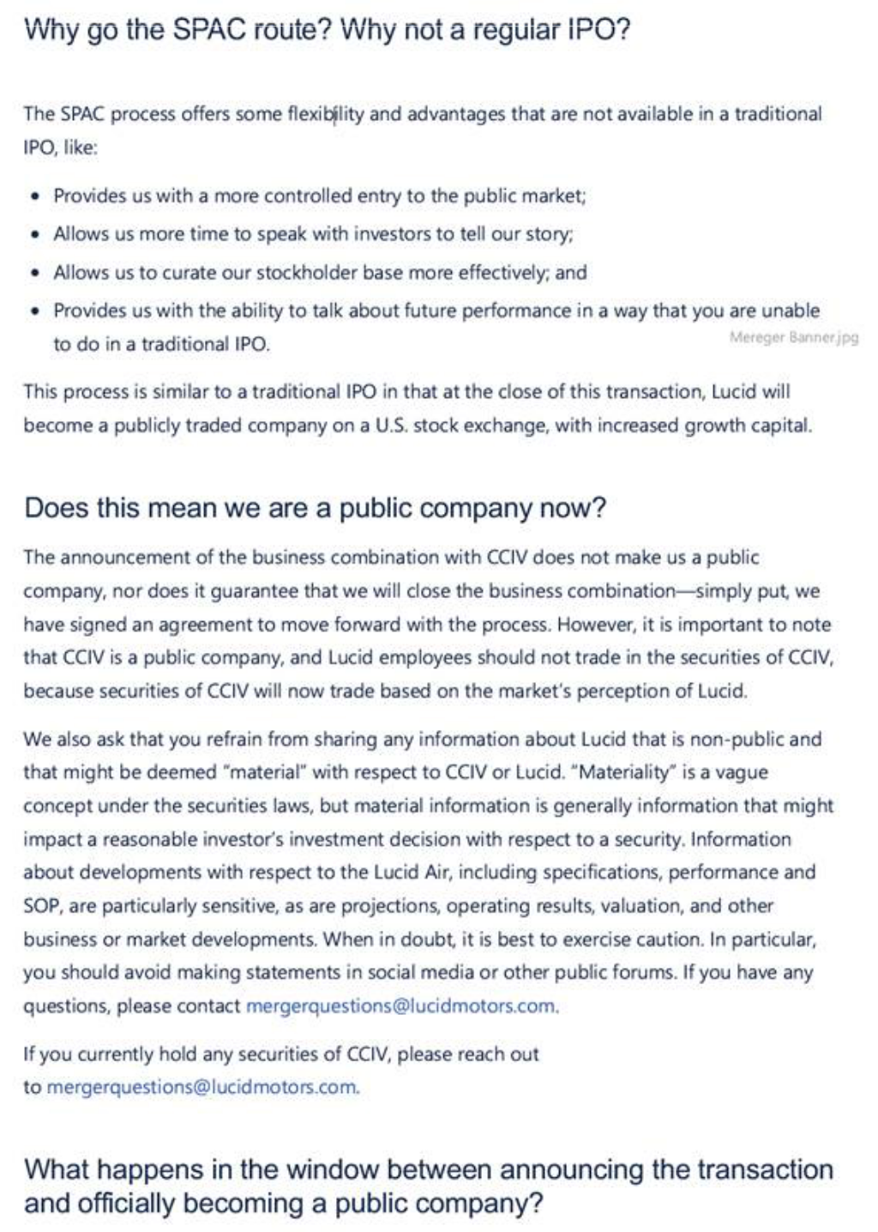

4

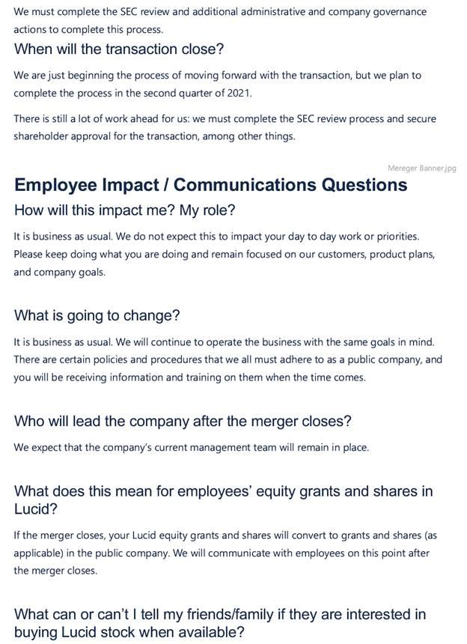

5



6

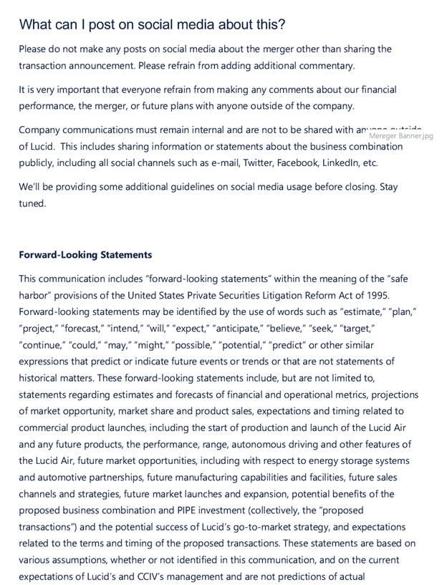

7

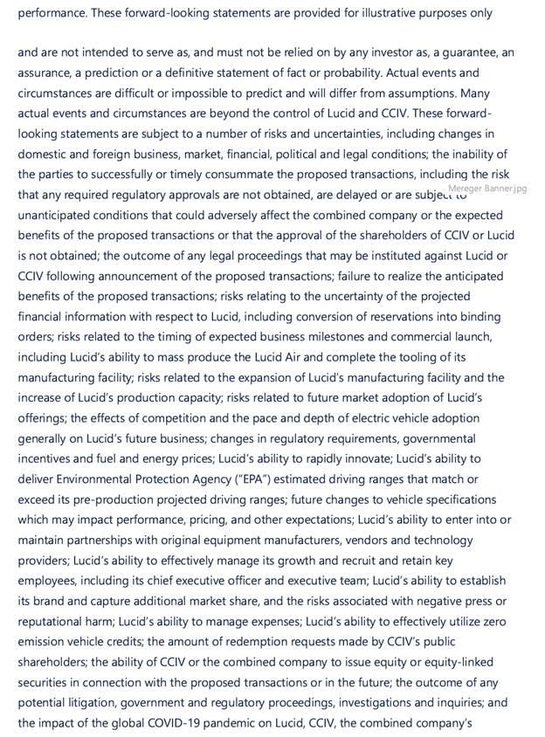

8

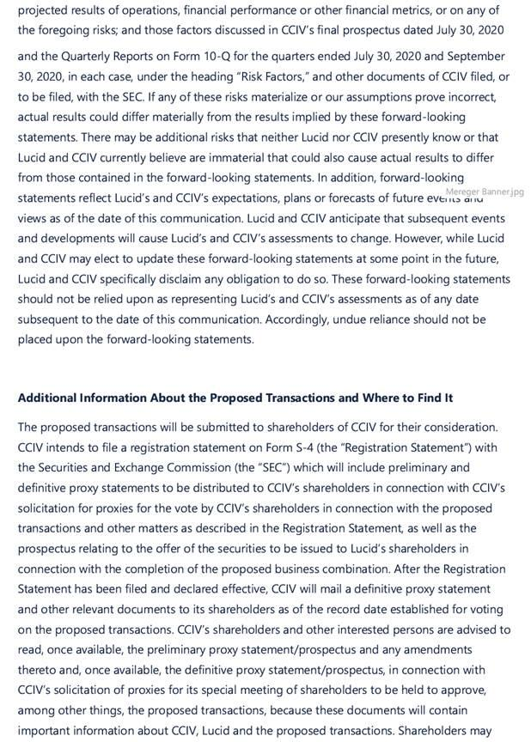

9

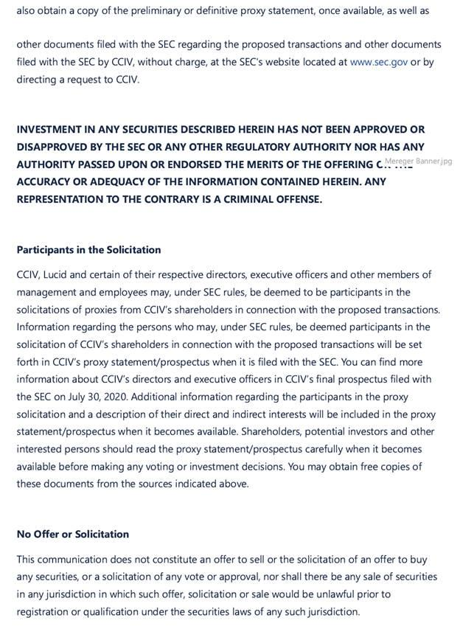

10

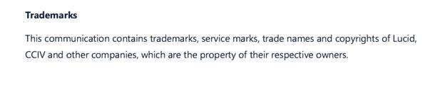

11

