SEC Form 3
FORM 3 | UNITED STATES SECURITIES AND EXCHANGE COMMISSION  Washington, D.C. 20549  INITIAL STATEMENT OF BENEFICIAL OWNERSHIP OF SECURITIES  Filed pursuant to Section 16(a) of the Securities Exchange Act of 1934  or Section 30(h) of the Investment Company Act of 1940
  OMB APPROVAL
  OMB Number: | 3235-0104
  Estimated average burden
  hours per response: | 0.5
1. Name and Address of Reporting Person*  (Street) | 2. Date of Event Requiring Statement (Month/Day/Year)  04/15/2026 | 3. Issuer Name and Ticker or Trading Symbol  Lucid Group, Inc. [ LCID ]
  Napoli Silvio
  (Last) | (First) | (Middle)
  C/O LUCID GROUP, INC.
  7373 GATEWAY BOULEVARD
  NEWARK | CA | 94560
  (City) | (State) | (Zip)
 |  | 4. Relationship of Reporting Person(s) to Issuer  (Check all applicable) | 5. If Amendment, Date of Original Filed (Month/Day/Year)
   | Director |  | 10% Owner
   | Officer (give title below) |  | Other (specify below)
6. Individual or Joint/Group Filing (Check Applicable Line)
Form filed by One Reporting Person
Form filed by More than One Reporting Person

Table I - Non-Derivative Securities Beneficially Owned
1. Title of Security (Instr. 4) | 2. Amount of Securities Beneficially Owned (Instr. 4) | 3. Ownership Form: Direct (D) or Indirect (I) (Instr. 5) | 4. Nature of Indirect Beneficial Ownership (Instr. 5)
Table II - Derivative Securities Beneficially Owned
(e.g., puts, calls, warrants, options, convertible securities)
1. Title of Derivative Security (Instr. 4) | 2. Date Exercisable and Expiration Date (Month/Day/Year) |  | 3. Title and Amount of Securities Underlying Derivative Security (Instr. 4) |  | 4. Conversion or Exercise Price of Derivative Security | 5. Ownership Form: Direct (D) or Indirect (I) (Instr. 5) | 6. Nature of Indirect Beneficial Ownership (Instr. 5)
1. Title of Derivative Security (Instr. 4) | Date Exercisable | Expiration Date | Title | Amount or Number of Shares | 4. Conversion or Exercise Price of Derivative Security | 5. Ownership Form: Direct (D) or Indirect (I) (Instr. 5) | 6. Nature of Indirect Beneficial Ownership (Instr. 5)
Explanation of Responses:
Remarks:
Exhibit 24 - Power of Attorney
No securities are beneficially owned.
 | /s/ Bruce Wang, as attorney-in-fact for Silvio Napoli | 04/17/2026
 | ** Signature of Reporting Person | Date
Reminder: Report on a separate line for each class of securities beneficially owned directly or indirectly.
* If the form is filed by more than one reporting person, see Instruction 5 (b)(v).
** Intentional misstatements or omissions of facts constitute Federal Criminal Violations See 18 U.S.C. 1001 and 15 U.S.C. 78ff(a).
Note: File three copies of this Form, one of which must be manually signed. If space is insufficient, see Instruction 6 for procedure.
Persons who respond to the collection of information contained in this form are not required to respond unless the form displays a currently valid OMB Number.
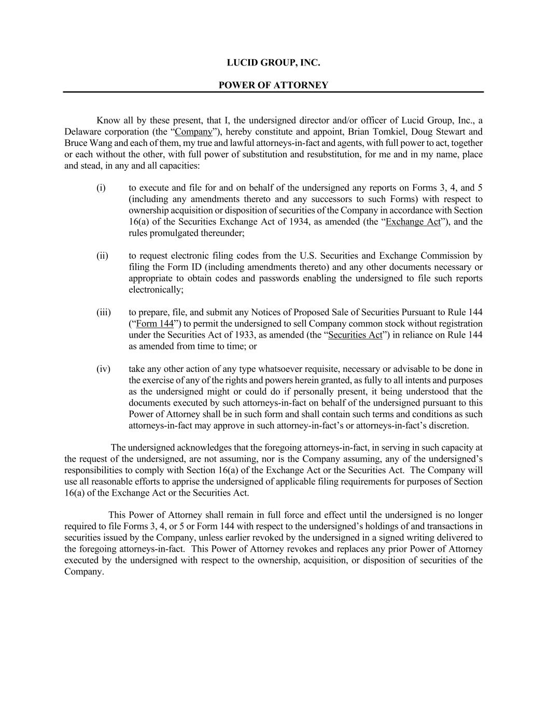
LUCID GROUP, INC. POWER OF ATTORNEY Know all by these present, that I, the undersigned director and/or officer of Lucid Group, Inc., a Delaware corporation (the “Company”), hereby constitute and appoint, Brian Tomkiel, Doug Stewart and Bruce Wang and each of them, my true and lawful attorneys-in-fact and agents, with full power to act, together or each without the other, with full power of substitution and resubstitution, for me and in my name, place and stead, in any and all capacities: (i) to execute and file for and on behalf of the undersigned any reports on Forms 3, 4, and 5 (including any amendments thereto and any successors to such Forms) with respect to ownership acquisition or disposition of securities of the Company in accordance with Section 16(a) of the Securities Exchange Act of 1934, as amended (the “Exchange Act”), and the rules promulgated thereunder; (ii) to request electronic filing codes from the U.S. Securities and Exchange Commission by filing the Form ID (including amendments thereto) and any other documents necessary or appropriate to obtain codes and passwords enabling the undersigned to file such reports electronically; (iii) to prepare, file, and submit any Notices of Proposed Sale of Securities Pursuant to Rule 144 (“Form 144”) to permit the undersigned to sell Company common stock without registration under the Securities Act of 1933, as amended (the “Securities Act”) in reliance on Rule 144 as amended from time to time; or (iv) take any other action of any type whatsoever requisite, necessary or advisable to be done in the exercise of any of the rights and powers herein granted, as fully to all intents and purposes as the undersigned might or could do if personally present, it being understood that the documents executed by such attorneys-in-fact on behalf of the undersigned pursuant to this Power of Attorney shall be in such form and shall contain such terms and conditions as such attorneys-in-fact may approve in such attorney-in-fact’s or attorneys-in-fact’s discretion. The undersigned acknowledges that the foregoing attorneys-in-fact, in serving in such capacity at the request of the undersigned, are not assuming, nor is the Company assuming, any of the undersigned’s responsibilities to comply with Section 16(a) of the Exchange Act or the Securities Act. The Company will use all reasonable efforts to apprise the undersigned of applicable filing requirements for purposes of Section 16(a) of the Exchange Act or the Securities Act. This Power of Attorney shall remain in full force and effect until the undersigned is no longer required to file Forms 3, 4, or 5 or Form 144 with respect to the undersigned’s holdings of and transactions in securities issued by the Company, unless earlier revoked by the undersigned in a signed writing delivered to the foregoing attorneys-in-fact. This Power of Attorney revokes and replaces any prior Power of Attorney executed by the undersigned with respect to the ownership, acquisition, or disposition of securities of the Company.


IN WITNESS WHEREOF, the undersigned has caused this Power of Attorney to be executed as of this 16th Day of April 2026. /s/ Silvio Napoli Name: Silvio Napoli

