Filed by Churchill Capital Corp IV
pursuant to Rule 425 under the Securities Act of 1933
and deemed filed pursuant to Rule 14a-12
under the Securities Exchange Act of 1934

Subject Company: Churchill Capital Corp IV
Commission File No. 001-39408

BofA Securities 2021 Automotive Summit
March 30, 2021

Peter Rawlinson, CEO and CTO of Lucid Motors, joined the BofA Securities 2021 Automotive Summit to discuss Lucid Motors.

TRANSCRIPT

Fitz Middleton: I’ll turn the floor over to you for your presentation and I’ll remind the audience that they can manually access the full presentation on the right-hand side of their screen.

Peter Rawlinson: Thank you so much Fitz for that generous introduction. And wherever you’re joining us from today, whether it’s good morning, good afternoon -- I guess it’s good afternoon in New York – hello to everyone from here in the heart of Silicon Valley where I’m at Lucid’s headquarters.

If you look at slide number 1, this is our car, the Lucid Air, and we’re really close to getting this into production now in our new factory in Arizona. We’re going to start selling these to members of the public in the second half of 2021. It’s coming soon.

And if we skip then to slide number 4 please, our mission really is to inspire the adoption of sustainable transportation. I really believe that we’ve got an impending environmental crisis and that mankind needs to move to sustainable mobility. And it needs to do that urgently.

Our first product, Lucid Air there, is unashamedly a high-end product. We’re starting the Dream Edition after the federal tax incentives at $161,500. We’re going to bring the price point down to under $70,000 as soon as possible and bring successively more affordable, more reachable cars into the marketplace, increasing the volume as we progress, throughout this decade.

Moving to slide 5, we recognize that it’s not just about electric cars or even creating the first product, the Lucid Air, this is about defining a new brand, creating a new brand. And our brand draws upon from heart and mind, the state of California, the heart, the iconic landscape, the dream that is the California dream, California cool if you like.

And we link that with mind, the associations with Silicon Valley technology, that this place is so famous for. And I think that those heart and mind value propositions resonate internationally.

Moving – that was slide 5, sorry. So moving on to slide 6. This is our first product, the Lucid Air and we’re unashamedly starting with a high-end product. But this has to be a technological tour de force. Why? Because we’re up against Mercedes Benz. This is a Mercedes competitor. We’re up against Mercedes S-Class. We’re up against BMW’s 7 Series and the Audi A8. These are grandee marks, that all have one thing in common, they’re gasoline powered.

But behold, Mercedes EQS is coming out this year. That’s great. So this is going to go head to head with the new electric offering from Mercedes. So we have to be the best technology play. That is what we’ll build our brand proposition upon.

So let’s take a look inside. Slide 7 shows you the interior of the car. In particular here you see this executive rear seating inspired by aircraft seats, which is an option we’ll bring in for 2023. The car is designed around a revolutionary new construct, which we call the Space Concept. This is where we make the car smaller and more compact on the outside and more roomy and more luxurious on the inside, with more leg and comfort.

And how have we been able to achieve that? By miniaturizing the electric powertrain. So it tees up more room for the people. But in order to do that, we had to master electric powertrain technology in-house. And that’s a core capability in this company.

Moving on to slide 8, you see the standard bench-style rear seat we’re actually launching the car with this year. It’s four-stroke, five-seater sedan. And moving up front to the cockpit in slide number 9, you see this beautiful what we call the glass cockpit, this curved multi-screen touchscreen array, in line of sight with the driver, augmented by a retractable center screen for deeper dive immersive functions.

We’ve taken the approach that in essence, less is more, in terms of the screens. We’ve not gone for a huge oversize screen system. We feel that this is discrete, imminently usable; understated; and it’s super safe. It’s on line of sight with the driver and providing great functionality and great ergonomics.

Now, moving on to slide number 10. This really is the litmus test, in my view. This is kind of Peter’s view of the world in defining who’s who in the worlds of EV tech. And just as if you’re an Olympic sprinter, what is your time for the 100 meter sprint? That defines you as a sprinter. Don’t tell me how strong your legs are; how quickly you are to the blocks; how good you are on the last 10 meters of the dash. Tell me your time to a 100th of a second. Well, I think it’s 9.58 defines Usain Bolt.

Right. Well, I can distill EV tech companies down to one single metric and it’s efficiency. What I mean by that, it’s how far can I go for a given amount of energy? So it’s miles for kilowatt hour. And everybody, we’re going to have to get used to this. It’s the equivalent, the electric equivalent of miles per gallon. It’s miles per kilowatt hour.

And this is where risk stacks up compared with the other EV rudders and riders. And here you see just how far ahead Tesla is from all the others. This is why Tesla’s worth so much money. Here is the metric that discloses it all. This shows Tesla being five, six years ahead of the pack, in efficiency, is a core metric.

And look where Lucid is. We’re really focused on this. And this is not just due to batteries. This is our whole value proposition of our integrated electric powertrain.

So how does this stack up in terms of the product? And moving on to slide 11, we see here how our per car compares with the front-running electric vehicles. And what we’ve got really is a paradigm breaker. We see that Lucid Air can actually provide an unprecedented combination of range and efficiency.

And this was hither to help that these attributes were mutually exclusive, range and efficiency. You can either have one or the other. But actually, we’ve been able to combine them both, particularly so in our launch edition, the limited Dream Edition.

And then moving on to slide 12, you see just how Lucid Air compares with its natural market competitor, the Mercedes S-Class. And really, it’s hands-down in all objective metrics.

But subjectively, driving the car is a different world. It’s got shattering performance. It’s got great composure. It’s like a super sports car in a sedan format. More compact, more agile, more sporty, more fun to drive, imminently usable in a big city and yet, it’s got this super cool really very modern vibe to it. It’s redefining this post-luxury, this notion of post-luxury.

And then moving on to slide 13 we see four different trim levels of Lucid Air, which we’ll offer, starting with Dream Edition, over 1000 horsepower, and gradually moving down market, as I’ve said, gradually making the car more attainable. And what really excites me here is the Air Pure, which we plan to get to market next year at a price point below $70,000.

This makes this incredible machine, this incredible sporting sedan with amazing range and amazing attributes, much more in reach of many more people, which is really important for the environment.

And underpinning all this, if we look at slide number 14, we see the LEAP platform. This is the Lucid Electric Advanced Platform. And we’re going to use this not just for Lucid Air, but for our next product, the SUV, which would pull in Project Gravity. And Project Gravity is going to go into our factory in Arizona in 2023. And we’re going to get the factory ready for that.

And this skateboard platform is 100% designed in-house, embodying all the EV technology, entirely in-house. This is what differentiates us from so many of these other EV startups. The technology is all built in this platform.

Moving on to slide 15, we see Project Gravity. These are our sneak-peak preview shots. We’ve actually changed the design a bit since then and it’s much cooler, even cooler again. And we’re really going to reimage what an SUV can be, using this Space Concept, bigger on the inside, more compact on the outside, to make a three-row super, super sporting, all electric SUV with great range and great characteristics.

But this is just the beginning. Looking at slide 16 we see here we have a beguiling range of products planned for the next decade, a product plan which has been very carefully thought through.

Now, I’ve mentioned in-house technology. So if you move to slide 17, we see the five key categories of that technology. Battery pack; motor and transmission; inverter; our bidirectional charging, which we call the Wunderbox; and the software that combines all this together.

And I cannot place sufficient emphasis upon the fact that this is 100% created, engineered, conceived, heavily painted, in-house; and we’re manufacturing all the electric powertrain in our new factory in Arizona. This is too precious to entrust to outsource. This is our core IP, our core technology.

And as Fitz has said, our battery pack draws upon now a number of years’ experience, being the sole battery supplier to the World Championship Electric Race Car Series. Our motor and transmission have made dramatic advances in not just efficiency, but absolute compactness, our unit that’s 74 kilograms a drive unit, which comprises motor, transmission and inverter and differential, and produce up to 670 horsepower. And it’s I could fit that inside a standard airline flight bag. It’s quite remarkable.

Our inverter is a wonderful thing. We’re getting over 90 horsepower per liter. No one else is ever close. And this is partly due to our ultra-high voltage architecture, over 900 volts. Tesla uses a 400-volt system. That was based upon the tech that really powered Model X with the tech that was available back in 2010. Modern EVs are really moving to ultra-high voltages, Porche’s at 800 volts. Lucid Air will launch at 924 volts.

But it’s not just about our car technology, it’s the application of this technology for other things, other arenas and industry. So if you move to slide 18, I envisage, I have a vision for the company, to make Lucid Group of companies encompass three divisions. It’s our cars and it’s going to be energy storage and then the third division, our technologies as a technology supplier.

So on our energy storage, we’ve got our first prototype up and running here at our head office in California. We’re linking that to a solar farm off the roof. I think that’s going to happen just next week. And then we’re going to make a beta prototype version of that to really make our factory in Arizona much more sustainable, in terms of its energy utilization. And then, I hope to industrialize this as a system, commercialize it in 2022. That’s the vision.

And then as a technology supplier, the third division of Lucid Group, we’ve got a great example already with what we do for the world championship motor sport as a battery supplier. But my vision is that we could truly mass industrialize electric powertrain components and systems, in a way that no one has done before.

Right now we see components and systems, which are not truly designed for mass manufacture, kind of being forced into mass production. We’ve taken an approach of truly design engineering for mass production, from the outset. And that may surprise many, because you see, Lucid Air, the first product of ours, as a relatively high-end product, you think that could be quite expensive to manufacture. And yet it’s my passion to make the electrification of that car truly mass productionizable, and very cost effective as a consequence.

And that’s what’s really going to have a big impact upon the world. And that’s why I want to supply our tech, not just to other car manufacturers who may not have that sort of technology, but also perhaps we can help disrupt other industries, agriculture, heavy equipment, marine come to mind.

But furthermore, I think there’s going to be an explosion of eVTOL aircraft in the next decade. And I think we’ve got at Lucid what all those electric aircraft companies need, which is really gravimetrically energy dense and power dense, gravimetrically power dense as well, integrated electric powertrain system, battery, motor, transmission, inverter and the software. Turnkey solution. It’s just a gift for eVTOL.

Now I mentioned a lot about design for mass production and I think there’s a great slide here on slide 19. If you move to slide 19, you see a great example. This is our battery module. We’re taken a modular approach to the way we build our world-class battery pack. And these modules are actually on display. We have six stores open now across the U.S., two in Silicon Valley, two in Los Angeles, and two in Florida.

We’re opening and very proud to be opening a store in Manhattan in the Meatpacking District in the week of the 25th of April. So please if you get a chance, come along and check that out.

And this is a module which is a single injection-moulded part where all the electrical connections in these bus bars that you see, these finger style bus bars, are a Lucid world paint, are all obviously encapsulation moulded. They’re moulded as a single shot integrally with the plastic. This is like a Lego brick. It can be churned out by the millions.

And one of these holds 321 700 cells which we secure from LG Chem. And each one of these modules represents just over five kilowatt hours. So we can have a modular pack which runs at different energy capacities and even different voltages, through this Lego brick approach.

No one else is making this as productionizable as this. This is a single part, a robot puts all these connections into the mould first. The plastic is shot, out pops the single part, which is the main structure and electrical for architecture for our module. Super, super mass producible.

And we make these in our new LMP plant, which leads to slide number 20. We have two factories in Arizona. One is dedicated specifically to make our integrated powertrain. This is where we make the battery modules that you’ve just seen; and put those into a pack – we put 22 of these into our Lucid Air pack for the extended range. And you’ve got just 18 of them into the standard pack.

And what do we do with that extra space? Well, where we leap those 4 to make go from 22 down to 18, we trade extra space in the rear passenger’s footwell to make the ergonomics a little bit better. So there’s a little trade in the car to choosing super long range or a very good range with enhanced rear seat ergonomics.

We do this – we make all these parts, our systems, in our powertrain manufacturing plant. That’s where we make the battery pack, motors; we assemble the transmissions; and we make our Wunderbox; we make the inverter, the whole system.

And then that just goes down the road to slide number 21. We take by truck in slide 20, five miles down the road to slide 21, which is our AMP factory in Arizona. Now this is our very first purpose-built factory in North America for electric cars. And what you have here is a factory we designed and engineered and conceived and got manufactured and create, built in record time.

We started construction there in December of 2019; and we actually had a pilot line or prototype cars being created there in September of 2020. And you see the two buildings there, this is slide 21. The building in the foreground is our body shop and that’s highly automated. It’s full of robots. And that’s where we make the body shell for the Lucid Air.

And we make that out of three key technologies, which we bring to bear, stampings, extrusions and castings. And these are riveted, self-piercing riveted and flow-drill screwed together with an epoxy adhesive. So this is aircraft style construction, state of the art. The car is not spot-welded together. It’s built like an aircraft. It’s bonded and riveted. And that’s the building in the foreground that makes that.

So then you can see just a little connection between the two buildings at the back of the building in the foreground. It goes into the big double-story building in the background, which is our big paint shop. And what we’ve done is we’ve invested long term, a long-term strategy. I think long term. I think in terms of 15 year plans for the company.

And that site is good in its fullest form for 365,000 units per annum. And what we’ve done is we’ve built and invested in a paint shop building, which will serve us for that full 365,000 per annum volume, later in this decade. And what we’ve been able to do is use the downsize, the downstairs of this oversized paint shop, to actually use as our general assembly floor to save money for the immediate term.

So actually, we’re building the main assembly lines downstairs in what ultimately will all be paint, but we’re using just the upstairs of the paint shop. And that factory as it stands is up and running already. Because we’ve already started building pre-production units of Lucid Air.

We’ve just recently taken the delivery of about the 30th of a run of about a hundred that we’re going to make now on our run-up to production, where we’re really finessing the quality. Each one just baby steps gets a little bit better quality.

And we’ve got 250 suppliers from right round the world supplying anecdotally around 3,000 parts. Many of them have done very well against the backdrop of the pandemic. But many have struggled. And we’re really helping those suppliers help us, because a chain is only as strong as its weakest link. And it’s exactly the same with the car.

We need to get the quality right and we’ve decided that it’s got to be quality, quality, quality. And that will take what time is necessary to get this right. And that’s why we’re building all these production, pre-production cars right now as I speak.

I’m particularly proud though of the standard of the paint that’s come from our paint shop there. It’s world class. It’s actually the best – I would say it’s the best water-based paint finish I’ve ever seen. It’s right up there. And we just need to get all the parts to that level of quality. Many of them are there. We’re going to gradually funnel this to a super quality product and get that ready for start of production in the second half of this year.

Now, I spoke a lot about the product and also the factory. There’s a third key pillar of activities that’s going on within the company. And that leads me to slide number 22. And here we see a great example of the Lucid showrooms. As I say, we’ve opened six so far. One here in Silicon Valley at our headquarters. We’ve got another one at Valley Fair in San Jose. We’ve got one in Beverly Hills and one at Century City in West LA. And we’ve opened in Miami and West Palm Beach.

And in about three weeks’ time I hope to have the opportunity to visit our store, for our store opening in Manhattan. And that will be the 7th. We plan to have about 22 showrooms, which we call studios, and service centers open by the end of this year, right across the USA. And we are positioning those strategically to match the demographics of our preorders.

Now we’re also supporting that with a Lucid mobile service van, because we’re cognizant that we can’t possibly build out a sufficient real estate covering the geography of the US in the timescale. But we will have a great advantage here. Because the cars are all super connected, they will be able to feed back data to us of their state of health and well-being on a regular basis, throughout their life. So we should, in a very high proportion of cases, have forewarning of any ailment of the car before it actually happens.

And if you move to slide 23, I think this shows some of these locations which are currently planned. And you get a real sense for the vibe and the ambiance of how the architecture and design sensibility of these stores and of these studios, really set off the car to best effect. Again, it’s this fusion of art and science of architectural sensibility, the two pillars of the brand. The heart and mind, the California cool meets the Silicon Valley tech.

So really, slide 24, that concludes my presentation. I hope you found this useful. I hope you found it a useful update. We’re all terribly excited here, working damn hard to make this a reality. I’ve always told my team that until we get a car sold to customers, we haven’t achieved a damn thing. And I still stand by that. I’m really bullish though that we’ve got some amazing technology that’s really real.

And I really hope to be able to share that with you in the very near future. We’ll soon be able to have cars which we can allow non-Lucid personnel to actually drive and experience. Up ‘til now, that’s not been possible, because of the development stage of the car. But that’s going to come in the near future; and it will be a real honor for me to allow, metaphorically, hand the keys to others to experience this wonderful thing. Thank you so much for your time, enjoy the presentation. Thank you.

Fitz Middleton: Peter, thank you very much. It’s fascinating work you guys are up to. And again, on behalf of BofA and for myself, thank you and your team for the time today and for joining us at the Auto Summit. Hopefully we’ll be able to do it in person one day sooner, rather than later. We appreciate it.

Peter Rawlinson: Thank you so much Fitz. Thanks for the opportunity. I really appreciate it. Thanks.

PRESENTATION

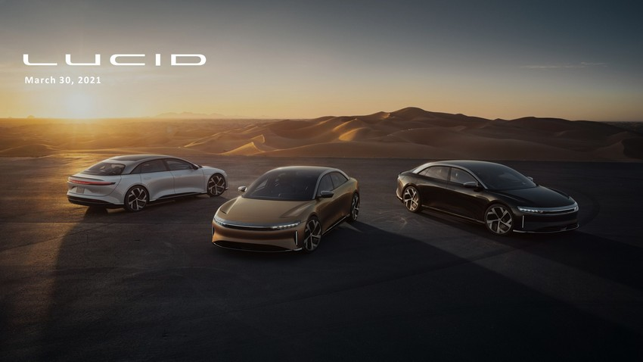
March 30, 2021

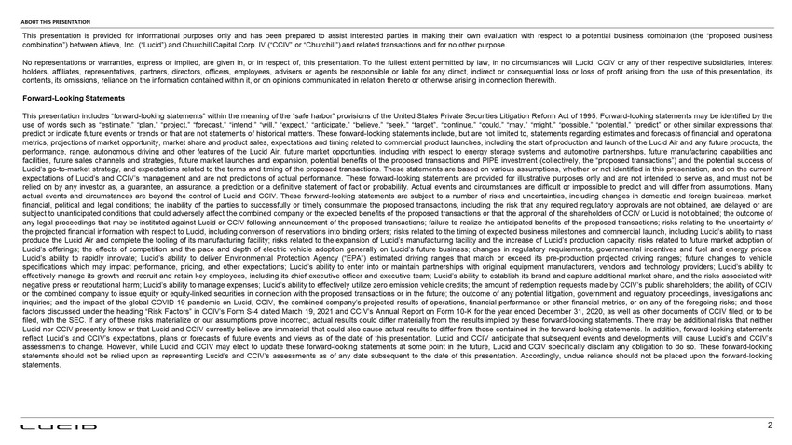
ABOUT THIS PRESENTATION This presentation is provided for informational purposes only and has been prepared to assist interested parties in making their own evaluation with respect to a potential business combination (the “proposed business combination”) between Atieva, Inc . (“Lucid”) and Churchill Capital Corp . IV (“CCIV” or “Churchill”) and related transactions and for no other purpose . No representations or warranties, express or implied, are given in, or in respect of, this presentation . To the fullest extent permitted by law, in no circumstances will Lucid, CCIV or any of their respective subsidiaries, interest holders, affiliates, representatives, partners, directors, officers, employees, advisers or agents be responsible or liable for any direct, indirect or consequential loss or loss of profit arising from the use of this presentation, its contents, its omissions, reliance on the information contained within it, or on opinions communicated in relation thereto or otherwise arising in connection therewith . Forward - Looking Statements This presentation includes “forward - looking statements” within the meaning of the “safe harbor” provisions of the United States Private Securities Litigation Reform Act of 1995 . Forward - looking statements may be identified by the use of words such as “estimate,” “plan,” “project,” “forecast,” “intend,” “will,” “expect,” “anticipate,” “believe,” “seek,” “target”, “continue,” “could,” “may,” “might,” “possible,” “potential,” “predict” or other similar expressions that predict or indicate future events or trends or that are not statements of historical matters . These forward - looking statements include, but are not limited to, statements regarding estimates and forecasts of financial and operational metrics, projections of market opportunity, market share and product sales, expectations and timing related to commercial product launches, including the start of production and launch of the Lucid Air and any future products, the performance, range, autonomous driving and other features of the Lucid Air, future market opportunities, including with respect to energy storage systems and automotive partnerships, future manufacturing capabilities and facilities, future sales channels and strategies, future market launches and expansion, potential benefits of the proposed transactions and PIPE investment (collectively, the “proposed transactions”) and the potential success of Lucid’s go - to - market strategy, and expectations related to the terms and timing of the proposed transactions . These statements are based on various assumptions, whether or not identified in this presentation, and on the current expectations of Lucid’s and CCIV’s management and are not predictions of actual performance . These forward - looking statements are provided for illustrative purposes only and are not intended to serve as, and must not be relied on by any investor as, a guarantee, an assurance, a prediction or a definitive statement of fact or probability . Actual events and circumstances are difficult or impossible to predict and will differ from assumptions . Many actual events and circumstances are beyond the control of Lucid and CCIV . These forward - looking statements are subject to a number of risks and uncertainties, including changes in domestic and foreign business, market, financial, political and legal conditions ; the inability of the parties to successfully or timely consummate the proposed transactions, including the risk that any required regulatory approvals are not obtained, are delayed or are subject to unanticipated conditions that could adversely affect the combined company or the expected benefits of the proposed transactions or that the approval of the shareholders of CCIV or Lucid is not obtained ; the outcome of any legal proceedings that may be instituted against Lucid or CCIV following announcement of the proposed transactions ; failure to realize the anticipated benefits of the proposed transactions ; risks relating to the uncertainty of the projected financial information with respect to Lucid, including conversion of reservations into binding orders ; risks related to the timing of expected business milestones and commercial launch, including Lucid’s ability to mass produce the Lucid Air and complete the tooling of its manufacturing facility ; risks related to the expansion of Lucid’s manufacturing facility and the increase of Lucid’s production capacity ; risks related to future market adoption of Lucid’s offerings ; the effects of competition and the pace and depth of electric vehicle adoption generally on Lucid’s future business ; changes in regulatory requirements, governmental incentives and fuel and energy prices ; Lucid’s ability to rapidly innovate ; Lucid’s ability to deliver Environmental Protection Agency (“EPA”) estimated driving ranges that match or exceed its pre - production projected driving ranges ; future changes to vehicle specifications which may impact performance, pricing, and other expectations ; Lucid’s ability to enter into or maintain partnerships with original equipment manufacturers, vendors and technology providers ; Lucid’s ability to effectively manage its growth and recruit and retain key employees, including its chief executive officer and executive team ; Lucid’s ability to establish its brand and capture additional market share, and the risks associated with negative press or reputational harm ; Lucid’s ability to manage expenses ; Lucid’s ability to effectively utilize zero emission vehicle credits ; the amount of redemption requests made by CCIV’s public shareholders ; the ability of CCIV or the combined company to issue equity or equity - linked securities in connection with the proposed transactions or in the future ; the outcome of any potential litigation, government and regulatory proceedings, investigations and inquiries ; and the impact of the global COVID - 19 pandemic on Lucid, CCIV, the combined company’s projected results of operations, financial performance or other financial metrics, or on any of the foregoing risks ; and those factors discussed under the heading “Risk Factors” in CCIV’s Form S - 4 dated March 19 , 2021 and CCIV’s Annual Report on Form 10 - K for the year ended December 31 , 2020 , as well as other documents of CCIV filed, or to be filed, with the SEC . If any of these risks materialize or our assumptions prove incorrect, actual results could differ materially from the results implied by these forward - looking statements . There may be additional risks that neither Lucid nor CCIV presently know or that Lucid and CCIV currently believe are immaterial that could also cause actual results to differ from those contained in the forward - looking statements . In addition, forward - looking statements reflect Lucid’s and CCIV’s expectations, plans or forecasts of future events and views as of the date of this presentation . Lucid and CCIV anticipate that subsequent events and developments will cause Lucid’s and CCIV’s assessments to change . However, while Lucid and CCIV may elect to update these forward - looking statements at some point in the future, Lucid and CCIV specifically disclaim any obligation to do so . These forward - looking statements should not be relied upon as representing Lucid’s and CCIV’s assessments as of any date subsequent to the date of this presentation . Accordingly, undue reliance should not be placed upon the forward - looking statements . 2

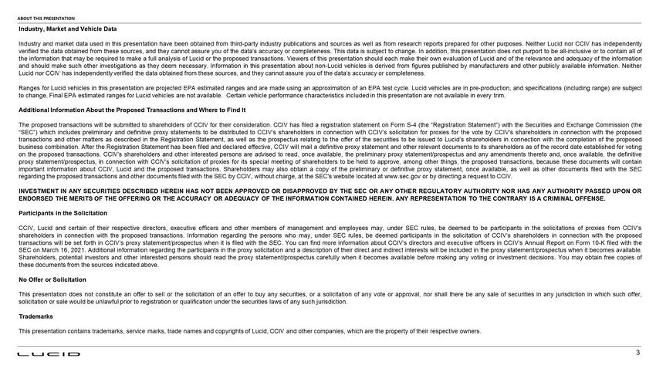
ABOUT THIS PRESENTATION Industry, Market and Vehicle Data Industry and market data used in this presentation have been obtained from third - party industry publications and sources as well as from research reports prepared for other purposes . Neither Lucid nor CCIV has independently verified the data obtained from these sources, and they cannot assure you of the data’s accuracy or completeness . This data is subject to change . In addition, this presentation does not purport to be all - inclusive or to contain all of the information that may be required to make a full analysis of Lucid or the proposed transactions . Viewers of this presentation should each make their own evaluation of Lucid and of the relevance and adequacy of the information and should make such other investigations as they deem necessary . Information in this presentation about non - Lucid vehicles is derived from figures published by manufacturers and other publicly available information . Neither Lucid nor CCIV has independently verified the data obtained from these sources, and they cannot assure you of the data’s accuracy or completeness . Ranges for Lucid vehicles in this presentation are projected EPA estimated ranges and are made using an approximation of an EPA test cycle . Lucid vehicles are in pre - production, and specifications (including range) are subject to change . Final EPA estimated ranges for Lucid vehicles are not available . Certain vehicle performance characteristics included in this presentation are not available in every trim . Additional Information About the Proposed Transactions and Where to Find It The proposed transactions will be submitted to shareholders of CCIV for their consideration . CCIV has filed a registration statement on Form S - 4 (the “Registration Statement”) with the Securities and Exchange Commission (the “SEC”) which includes preliminary and definitive proxy statements to be distributed to CCIV’s shareholders in connection with CCIV’s solicitation for proxies for the vote by CCIV’s shareholders in connection with the proposed transactions and other matters as described in the Registration Statement, as well as the prospectus relating to the offer of the securities to be issued to Lucid’s shareholders in connection with the completion of the proposed business combination . After the Registration Statement has been filed and declared effective, CCIV will mail a definitive proxy statement and other relevant documents to its shareholders as of the record date established for voting on the proposed transactions . CCIV’s shareholders and other interested persons are advised to read, once available, the preliminary proxy statement/prospectus and any amendments thereto and, once available, the definitive proxy statement/prospectus, in connection with CCIV’s solicitation of proxies for its special meeting of shareholders to be held to approve, among other things, the proposed transactions, because these documents will contain important information about CCIV, Lucid and the proposed transactions . Shareholders may also obtain a copy of the preliminary or definitive proxy statement, once available, as well as other documents filed with the SEC regarding the proposed transactions and other documents filed with the SEC by CCIV, without charge, at the SEC's website located at www . sec . gov or by directing a request to CCIV . INVESTMENT IN ANY SECURITIES DESCRIBED HEREIN HAS NOT BEEN APPROVED OR DISAPPROVED BY THE SEC OR ANY OTHER REGULATORY AUTHORITY NOR HAS ANY AUTHORITY PASSED UPON OR ENDORSED THE MERITS OF THE OFFERING OR THE ACCURACY OR ADEQUACY OF THE INFORMATION CONTAINED HEREIN . ANY REPRESENTATION TO THE CONTRARY IS A CRIMINAL OFFENSE . Participants in the Solicitation CCIV, Lucid and certain of their respective directors, executive officers and other members of management and employees may, under SEC rules, be deemed to be participants in the solicitations of proxies from CCIV’s shareholders in connection with the proposed transactions . Information regarding the persons who may, under SEC rules, be deemed participants in the solicitation of CCIV’s shareholders in connection with the proposed transactions will be set forth in CCIV’s proxy statement/prospectus when it is filed with the SEC . You can find more information about CCIV’s directors and executive officers in CCIV’s Annual Report on Form 10 - K filed with the SEC on March 16 , 2021 . Additional information regarding the participants in the proxy solicitation and a description of their direct and indirect interests will be included in the proxy statement/prospectus when it becomes available . Shareholders, potential investors and other interested persons should read the proxy statement/prospectus carefully when it becomes available before making any voting or investment decisions . You may obtain free copies of these documents from the sources indicated above . No Offer or Solicitation This presentation does not constitute an offer to sell or the solicitation of an offer to buy any securities, or a solicitation of any vote or approval, nor shall there be any sale of securities in any jurisdiction in which such offer, solicitation or sale would be unlawful prior to registration or qualification under the securities laws of any such jurisdiction . Trademarks This presentation contains trademarks, service marks, trade names and copyrights of Lucid, CCIV and other companies, which are the property of their respective owners . 3

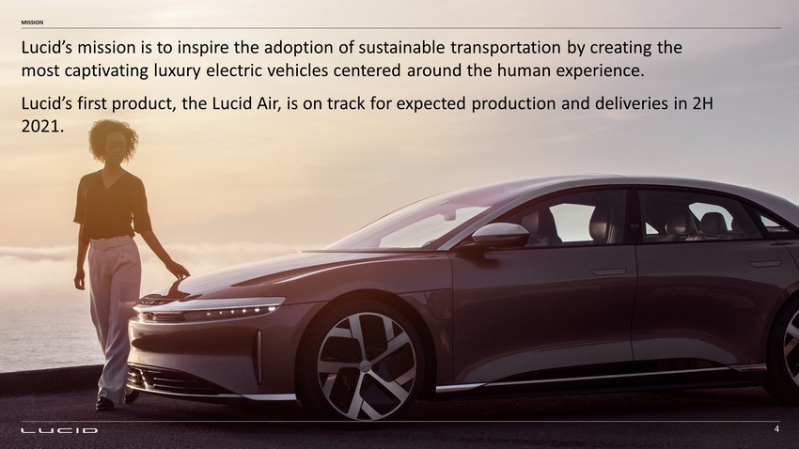
Lucid’s mission is to inspire the adoption of sustainable transportation by creating the most captivating luxury electric vehicles centered around the human experience. Lucid’s first product, the Lucid Air, is on track for expected production and deliveries in 2H 2021. MISSION 4

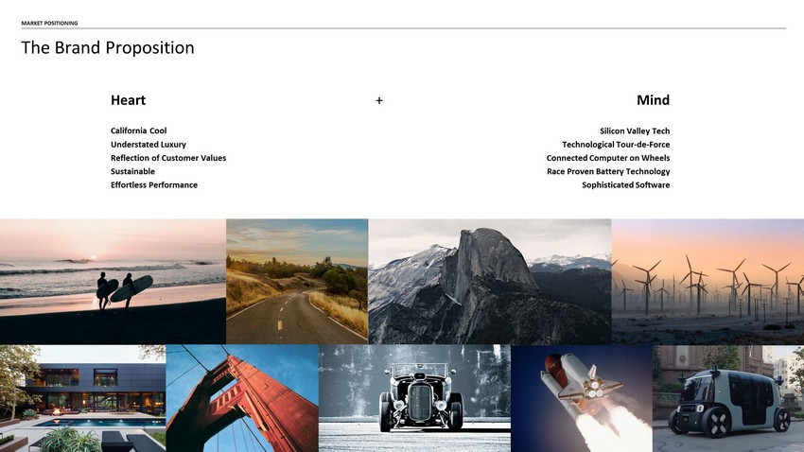
California Cool Understated Luxury Reflection of Customer Values Sustainable Effortless Performance Silicon Valley Tech Technological Tour - de - Force Connected Computer on Wheels Race Proven Battery Technology Sophisticated Software Heart + Mind MARKET POSITIONING The Brand Proposition

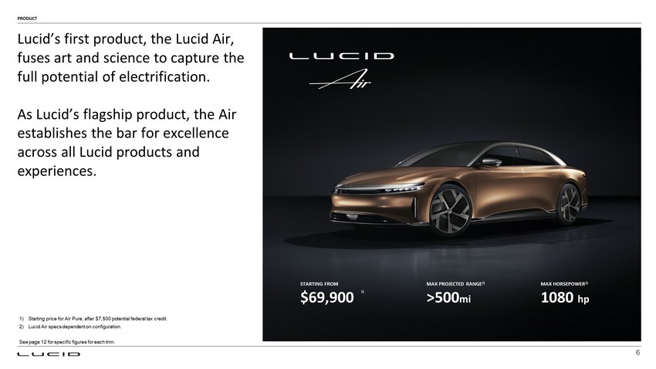
6 PRODUCT Lucid’s first product, the Lucid Air, fuses art and science to capture the full potential of electrification. As Lucid’s flagship product, the Air establishes the bar for excellence across all Lucid products and experiences. STARTING FROM $69,900 MAX PROJECTED RANGE 2) >500 mi MAX HORSEPOWER 2) 1080 hp 1) Starting price for Air Pure, after $7,500 potential federal tax credit. 2) Lucid Air specs dependent on configuration. See page 12 for specific figures for each trim. 1)

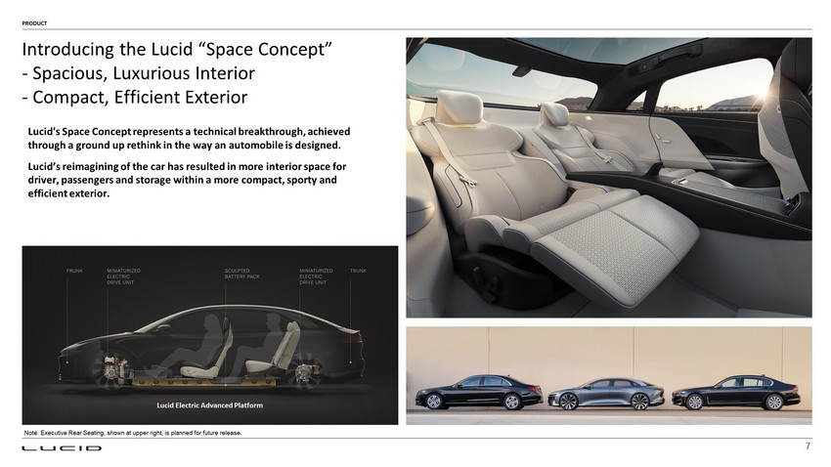
Lucid's Space Concept represents a technical breakthrough, achieved through a ground up rethink in the way an automobile is designed. Lucid’s reimagining of the car has resulted in more interior space for driver, passengers and storage within a more compact, sporty and efficient exterior. Lucid Electric Advanced Platform PRODUCT Introducing the Lucid “Space Concept” - Spacious, Luxurious Interior - Compact, Efficient Exterior Note: Executive Rear Seating, shown at upper right, is planned for future release. 7

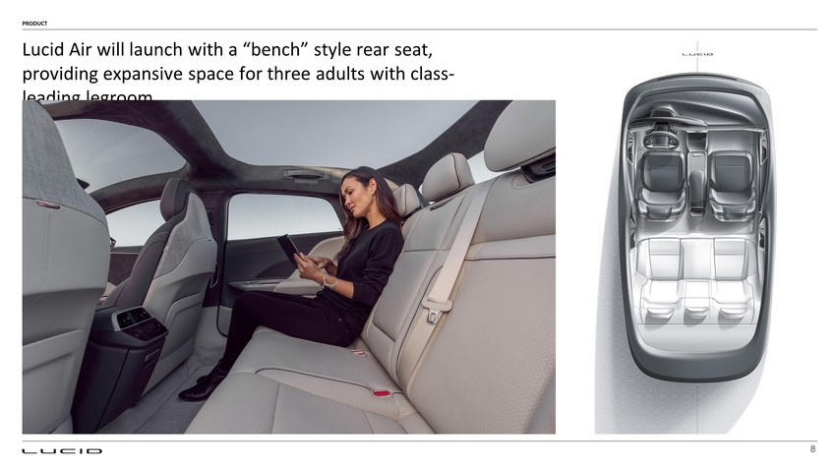
8 PRODUCT Lucid Air will launch with a “bench” style rear seat, providing expansive space for three adults with class - leading legroom.

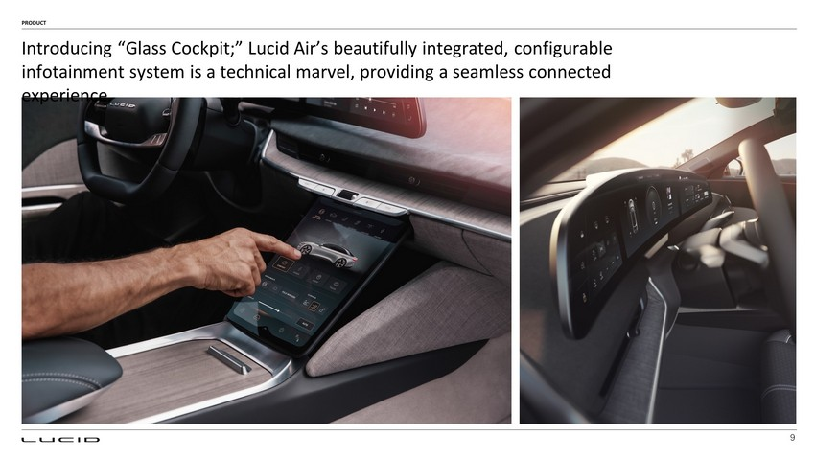
9 PRODUCT Introducing “Glass Cockpit;” Lucid Air’s beautifully integrated, configurable infotainment system is a technical marvel, providing a seamless connected experience.

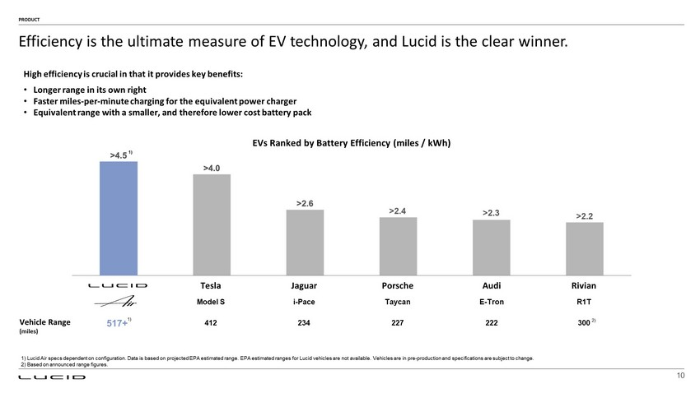
Vehicle Range (miles) Efficiency is the ultimate measure of EV technology, and Lucid is the clear winner. High efficiency is crucial in that it provides key benefits: • Longer range in its own right • Faster miles - per - minute charging for the equivalent power charger • Equivalent range with a smaller, and therefore lower cost battery pack EVs Ranked by Battery Efficiency (miles / kWh) 412 234 222 227 300 2) PRODUCT 1) Model S i - Pace R1T E - Tron Taycan 10 Tesla Jaguar Porsche Audi Rivian 517+ 1) 1) Lucid Air specs dependent on configuration. Data is based on projected EPA estimated range. EPA estimated ranges for Lucid ve hicles are not available. Vehicles are in pre - production and specifications are subject to change. 2) Based on announced range figures.

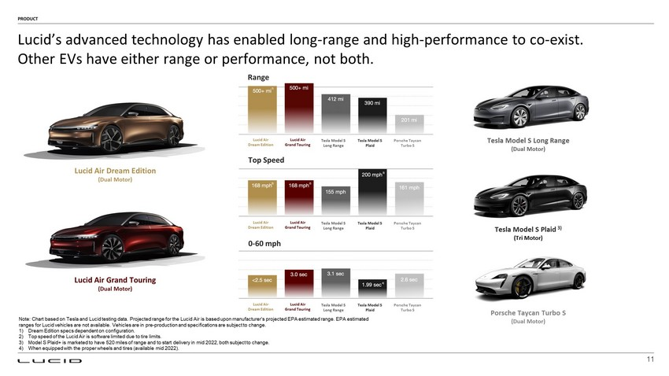
Lucid’s advanced technology has enabled long - range and high - performance to co - exist. Other EVs have either range or performance, not both. PRODUCT 11 Tesla Model S Long Range (Dual Motor) Tesla Model S Plaid 3) (Tri Motor) Lucid Air Dream Edition Tesla Model S Long Range Tesla Model S Plaid Porsche Taycan Turbo S Range Top Speed 0 - 60 mph Note: Chart based on Tesla and Lucid testing data. Projected range for the Lucid Air is based upon manufacturer’s projected E PA estimated range. EPA estimated ranges for Lucid vehicles are not available. Vehicles are in pre - production and specifications are subject to change. 1) Dream Edition specs dependent on configuration. 2) Top speed of the Lucid Air is software limited due to tire limits. 3) Model S Plaid+ is marketed to have 520 miles of range and to start delivery in mid 2022, both subject to change. 4) When equipped with the proper wheels and tires (available mid 2022). Lucid Air Grand Touring Porsche Taycan Turbo S (Dual Motor) Lucid Air Grand Touring (Dual Motor) Lucid Air Dream Edition (Dual Motor) Lucid Air Dream Edition Tesla Model S Long Range Tesla Model S Plaid Porsche Taycan Turbo S Lucid Air Grand Touring Lucid Air Dream Edition Tesla Model S Long Range Tesla Model S Plaid Porsche Taycan Turbo S Lucid Air Grand Touring

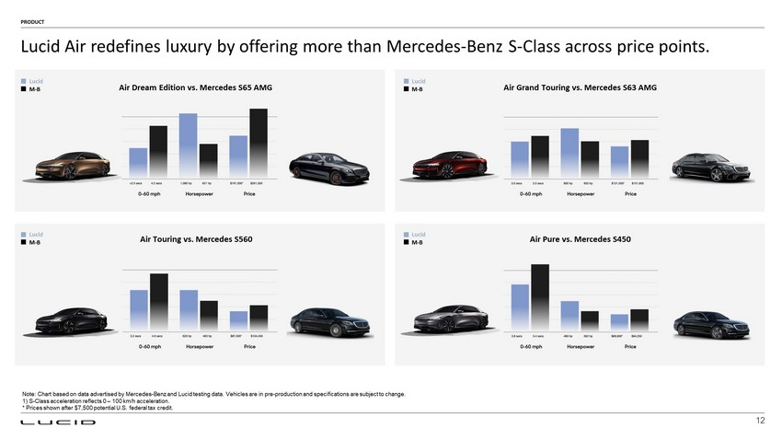
Lucid Air redefines luxury by offering more than Mercedes - Benz S - Class across price points. PRODUCT Air Dream Edition vs. Mercedes S65 AMG Air Grand Touring vs. Mercedes S63 AMG Air Touring vs. Mercedes S560 Note: Chart based on data advertised by Mercedes - Benz and Lucid testing data. Vehicles are in pre - production and specifications are subject to change. 1) S - Class acceleration reflects 0 – 100 km/h acceleration. * Prices shown after $7,500 potential U.S. federal tax credit. Air Pure vs. Mercedes S450 Lucid M - B Lucid M - B Lucid M - B Lucid M - B 12

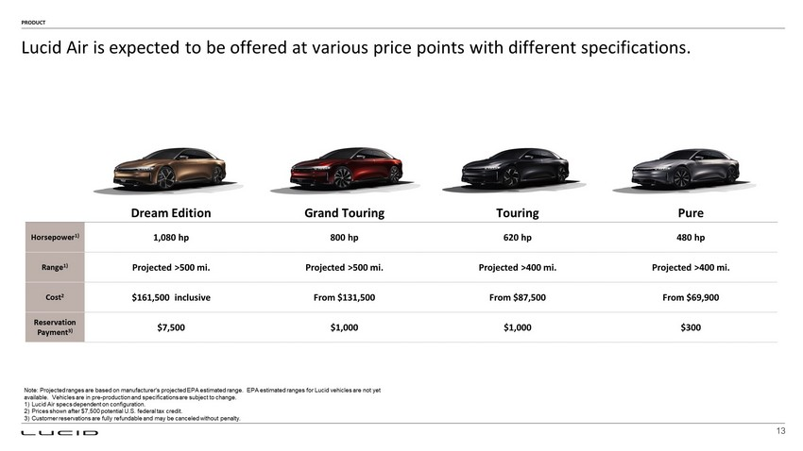
Dream Edition Grand Touring Touring Pure Horsepower 1) 1,080 hp 800 hp 620 hp 480 hp Range 1) Projected >500 mi. Projected >500 mi. Projected >400 mi. Projected >400 mi. Cost 2 $161,500 inclusive From $131,500 From $87,500 From $69,900 Reservation Payment 3) $7,500 $1,000 $1,000 $300 13 Note: Projected ranges are based on manufacturer's projected EPA estimated range. EPA estimated ranges for Lucid vehicles ar e n ot yet available. Vehicles are in pre - production and specifications are subject to change. 1) Lucid Air specs dependent on configuration. 2) Prices shown after $7,500 potential U.S. federal tax credit. 3) Customer reservations are fully refundable and may be canceled without penalty. PRODUCT Lucid Air is expected to be offered at various price points with different specifications.

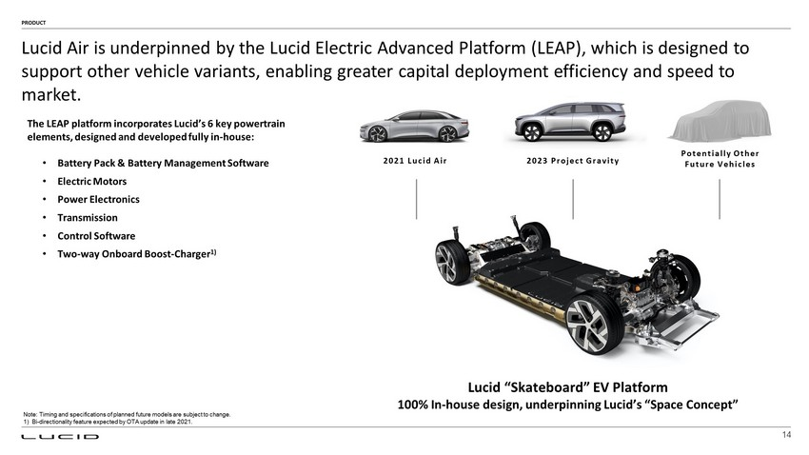
Lucid “Skateboard” EV Platform 100% In - house design, underpinning Lucid’s “Space Concept” The LEAP platform incorporates Lucid’s 6 key powertrain elements, designed and developed fully in - house: • Battery Pack & Battery Management Software • Electric Motors • Power Electronics • Transmission • Control Software • Two - way Onboard Boost - Charger 1) Lucid Air is underpinned by the Lucid Electric Advanced Platform ( LEAP), which is designed to support other vehicle variants, enabling greater capital deployment efficiency and speed to market. PRODUCT 202 1 Lucid Air 202 3 Project Gravity Potentially Other Future Vehicles Note: Timing and specifications of planned future models are subject to change. 1) Bi - directionality feature expected by OTA update in late 2021. 14

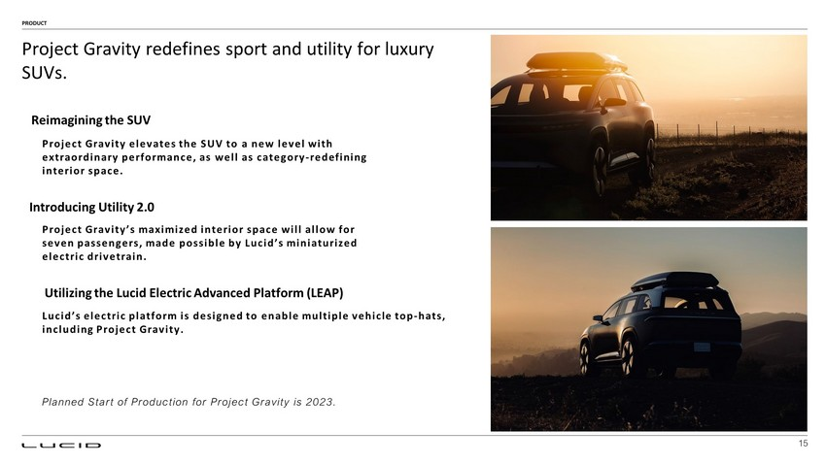
Project Gravity elevates the SUV to a new level with extraordinary performance, as well as category - redefining interior space. Reimagining the SUV Introducing Utility 2.0 Project Gravity’s maximized interior space will allow for seven passengers, made possible by Lucid’s miniaturized electric drivetrain. Utilizing the Lucid Electric Advanced Platform (LEAP) Lucid’s electric platform is designed to enable multiple vehicle top - hats, including Project Gravity. Project Gravity redefines sport and utility for luxury SUVs. PRODUCT Planned Start of Production for Project Gravity is 2023. 15

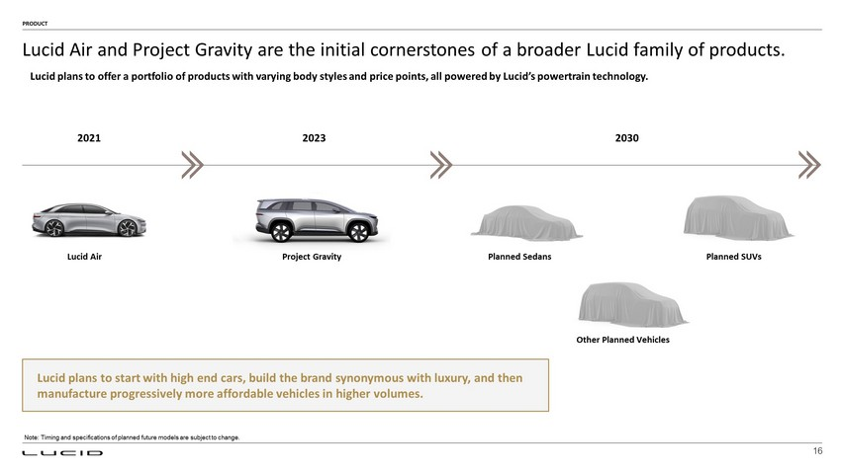
Lucid Air and Project Gravity are the initial cornerstones of a broader Lucid family of products. PRODUCT 2021 2023 2030 Lucid Air Project Gravity Planned Sedans Planned SUVs Other Planned Vehicles Lucid plans to offer a portfolio of products with varying body styles and price points, all powered by Lucid’s powertrain tec hno logy. Lucid plans to start with high end cars, build the brand synonymous with luxury, and then manufacture progressively more affordable vehicles in higher volumes. 16 Note: Timing and specifications of planned future models are subject to change.

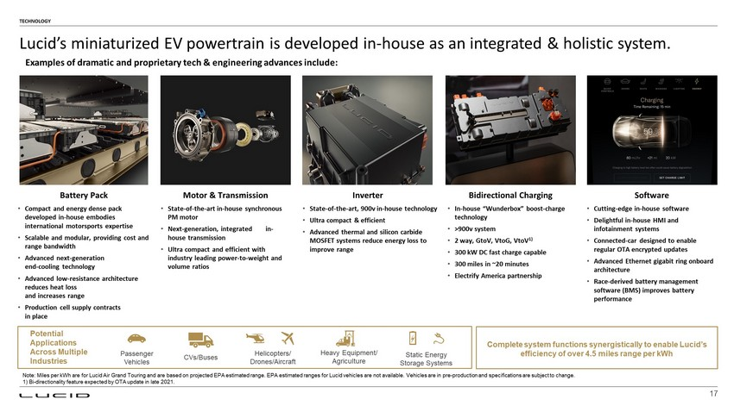
Battery Pack Motor & Transmission Inverter Software Potential Applications Across Multiple Industries CVs/Buses Helicopters/ Drones/Aircraft Static Energy Storage Systems Heavy Equipment/ Agriculture Passenger Vehicles • Compact and energy dense pack developed in - house embodies international motorsports expertise • Scalable and modular, providing cost and range bandwidth • Advanced next - generation end - cooling technology • Advanced low - resistance architecture reduces heat loss and increases range • Production cell supply contracts in place • State - of - the - art in - house synchronous PM motor • Next - generation, integrated in - house transmission • Ultra compact and efficient with industry leading power - to - weight and volume ratios • State - of - the - art, 900v in - house technology • Ultra compact & efficient • Advanced thermal and silicon carbide MOSFET systems reduce energy loss to improve range • Cutting - edge in - house software • Delightful in - house HMI and infotainment systems • Connected - car designed to enable regular OTA encrypted updates • Advanced Ethernet gigabit ring onboard architecture • Race - derived battery management software (BMS) improves battery performance TECHNOLOGY Lucid’s miniaturized EV powertrain is developed in - house as an integrated & holistic system. Bidirectional Charging • In - house “ Wunderbox ” boost - charge technology • >900v system • 2 way, GtoV , VtoG , VtoV 1) • 300 kW DC fast charge capable • 300 miles in ~20 minutes • Electrify America partnership Complete system functions synergistically to enable Lucid’s efficiency of over 4.5 miles range per kWh Note: Miles per kWh are for Lucid Air Grand Touring and are based on projected EPA estimated range. EPA estimated ranges for Luc id vehicles are not available. Vehicles are in pre - production and specifications are subject to change. 1) Bi - directionality feature expected by OTA update in late 2021. Examples of dramatic and proprietary tech & engineering advances include: 17

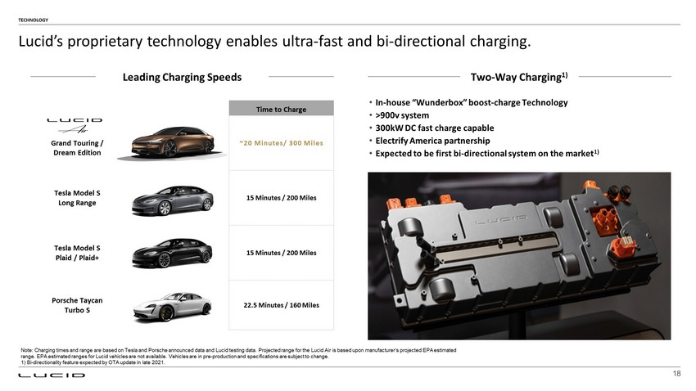
Time to Charge Grand Touring / Dream Edition ~20 Minutes/ 300 Miles Tesla Model S Long Range 15 Minutes / 200 Miles Tesla Model S Plaid / Plaid+ 15 Minutes / 200 Miles Porsche Taycan Turbo S 22.5 Minutes / 160 Miles TECHNOLOGY Lucid’s proprietary technology enables ultra - fast and bi - directional charging. Two - Way Charging 1) • In - house “ Wunderbox ” boost - charge Technology • >900v system • 300kW DC fast charge capable • Electrify America partnership • Expected to be first bi - directional system on the market 1) Note: Charging times and range are based on Tesla and Porsche announced data and Lucid testing data. Projected range for the Luc id Air is based upon manufacturer’s projected EPA estimated range. EPA estimated ranges for Lucid vehicles are not available. Vehicles are in pre - production and specifications are subject to change. 1) Bi - directionality feature expected by OTA update in late 2021. Leading Charging Speeds 18

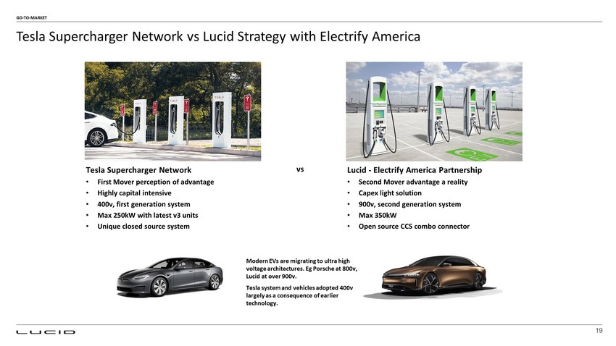
Tesla Supercharger Network vs Lucid Strategy with Electrify America GO - TO - MARKET Tesla Supercharger Network • First Mover perception of advantage • Highly capital intensive • 400v, first generation system • Max 250kW with latest v3 units • Unique closed source system Lucid - Electrify America Partnership • Second Mover advantage a reality • Capex light solution • 900v, second generation system • Max 350kW • Open source CCS combo connector Modern EVs are migrating to ultra high voltage architectures. Eg Porsche at 800v, Lucid at over 900v. Tesla system and vehicles adopted 400v largely as a consequence of earlier technology. vs 19

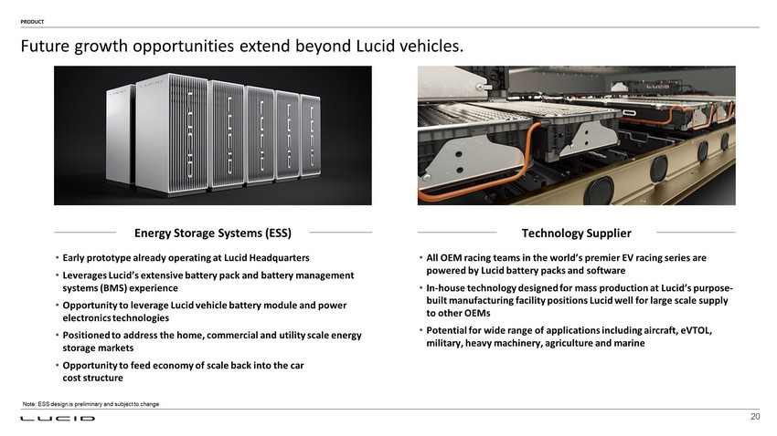
Energy Storage Systems (ESS) Technology Supplier • Early prototype already operating at Lucid Headquarters • Leverages Lucid’s extensive battery pack and battery management systems (BMS) experience • Opportunity to leverage Lucid vehicle battery module and power electronics technologies • Positioned to address the home, commercial and utility scale energy storage markets • Opportunity to feed economy of scale back into the car cost structure • All OEM racing teams in the world’s premier EV racing series are powered by Lucid battery packs and software • In - house technology designed for mass production at Lucid’s purpose - built manufacturing facility positions Lucid well for large scale supply to other OEMs • Potential for wide range of applications including aircraft, eVTOL , military, heavy machinery, agriculture and marine Future growth opportunities extend beyond Lucid vehicles. PRODUCT Note: ESS design is preliminary and subject to change 20

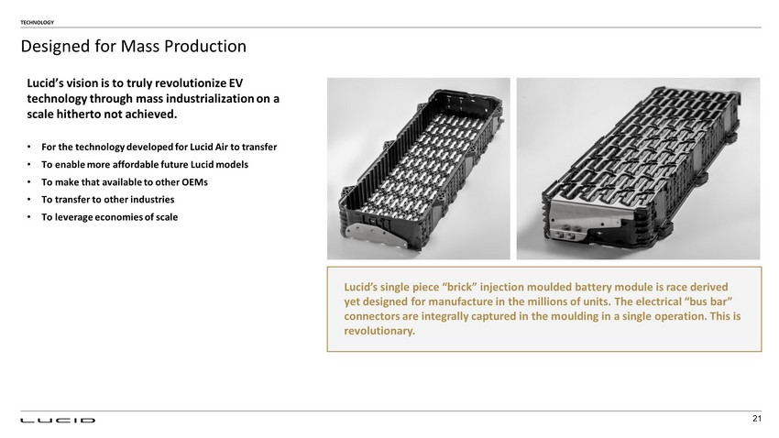
Designed for Mass Production TECHNOLOGY 21 Lucid’s vision is to truly revolutionize EV technology through mass industrialization on a scale hitherto not achieved. Lucid’s single piece “brick” injection moulded battery module is race derived yet designed for manufacture in the millions of units. The electrical “bus bar” connectors are integrally captured in the moulding in a single operation. This is revolutionary. • For the technology developed for Lucid Air to transfer • To enable more affordable future Lucid models • To make that available to other OEMs • To transfer to other industries • To leverage economies of scale

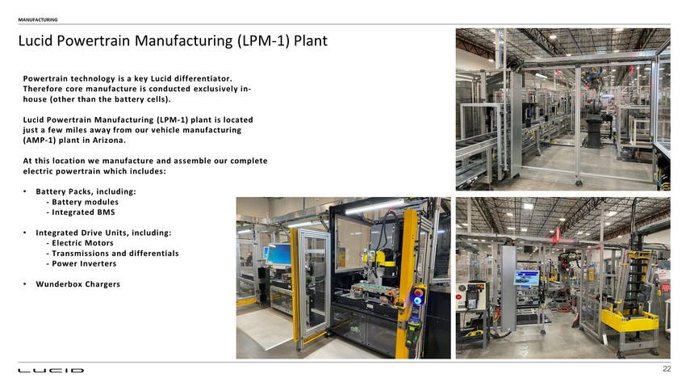
MANUFACTURING 22 Powertrain technology is a key Lucid differentiator. Therefore core manufacture is conducted exclusively in - house (other than the battery cells). Lucid Powertrain Manufacturing (LPM - 1) plant is located just a few miles away from our vehicle manufacturing (AMP - 1) plant in Arizona. At this location we manufacture and assemble our complete electric powertrain which includes: • Battery Packs, including: - Battery modules - Integrated BMS • Integrated Drive Units, including: - Electric Motors - Transmissions and differentials - Power Inverters • Wunderbox Chargers Lucid Powertrain Manufacturing (LPM - 1) Plant

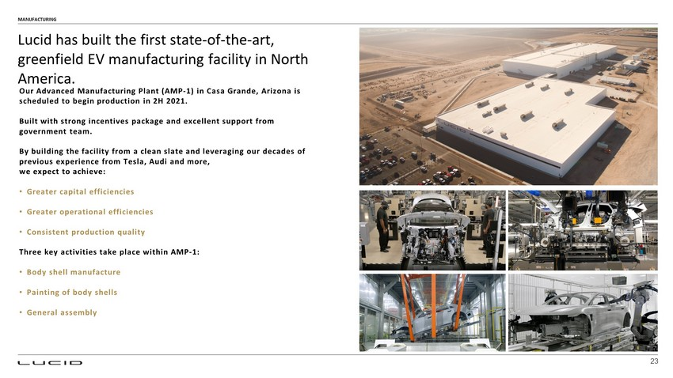
Our Advanced Manufacturing Plant (AMP - 1) in Casa Grande, Arizona is scheduled to begin production in 2H 2021. Built with strong incentives package and excellent support from government team. By building the facility from a clean slate and leveraging our decades of previous experience from Tesla, Audi and more, we expect to achieve: • Greater capital efficiencies • Greater operational efficiencies • Consistent production quality Three key activities take place within AMP - 1: • Body shell manufacture • Painting of body shells • General assembly MANUFACTURING Lucid has built the first state - of - the - art, greenfield EV manufacturing facility in North America. 23

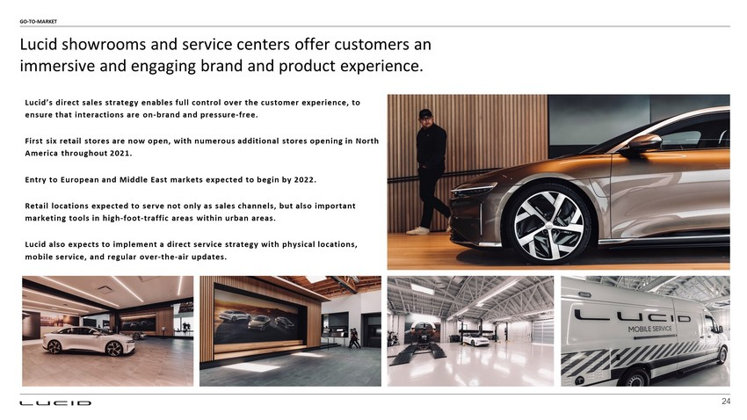
Lucid’s direct sales strategy enables full control over the customer experience, to ensure that interactions are on - brand and pressure - free. First six retail stores are now open, with numerous additional stores opening in North America throughout 2021. Entry to European and Middle East markets expected to begin by 2022. Retail locations expected to serve not only as sales channels, but also important marketing tools in high - foot - traffic areas within urban areas. Lucid also expects to implement a direct service strategy with physical locations, mobile service, and regular over - the - air updates. Lucid showrooms and service centers offer customers an immersive and engaging brand and product experience. GO - TO - MARKET 24

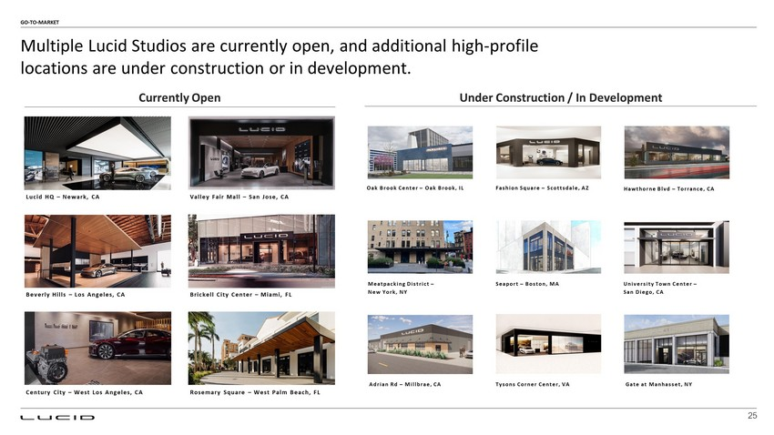
Century City – West Los Angeles, CA Multiple Lucid Studios are currently open, and additional high - profile locations are under construction or in development. Lucid HQ – Newark, CA Valley Fair Mall – San Jose, CA Beverly Hills – Los Angeles, CA Brickell City Center – Miami, FL GO - TO - MARKET Currently Open 25 Rosemary Square – West Palm Beach, FL University Town Center – San Diego, CA Fashion Square – Scottsdale, AZ Seaport – Boston, MA Oak Brook Center – Oak Brook, IL Meatpacking District – New York, NY Hawthorne Blvd – Torrance, CA Adrian Rd – Millbrae, CA Under Construction / In Development Tysons Corner Center, VA Gate at Manhasset, NY

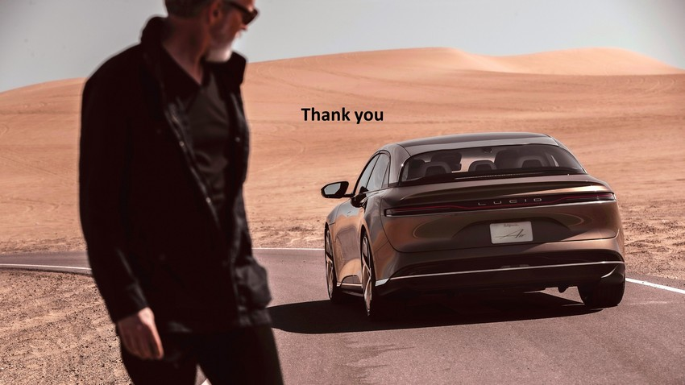
Thank you

IMPORTANT LEGAL INFORMATION

Forward-Looking Statements

This communication includes “forward-looking statements” within the meaning of the “safe harbor” provisions of the United States Private Securities Litigation Reform Act of 1995. Forward-looking statements may be identified by the use of words such as “estimate,” “plan,” “project,” “forecast,” “intend,” “will,” “expect,” “anticipate,” “believe,” “seek,” “target,” “continue,” “could,” “may,” “might,” “possible,” “potential,” “predict” or other similar expressions that predict or indicate future events or trends or that are not statements of historical matters. These forward-looking statements include, but are not limited to, statements regarding estimates and forecasts of financial and operational metrics, projections of market opportunity, market share and product sales, expectations and timing related to commercial product launches, including the start of production and launch of the Lucid Air and any future products, the performance, range, autonomous driving and other features of the Lucid Air, future market opportunities, including with respect to energy storage systems and automotive partnerships, future manufacturing capabilities and facilities, future sales channels and strategies, future market launches and expansion, potential benefits of the proposed business combination and PIPE investment (collectively, the “proposed transactions”) and the potential success of Lucid’s go-to-market strategy, and expectations related to the terms and timing of the proposed transactions. These statements are based on various assumptions, whether or not identified in this communication, and on the current expectations of Lucid’s and CCIV’s management and are not predictions of actual performance. These forward-looking statements are provided for illustrative purposes only and are not intended to serve as, and must not be relied on by any investor as, a guarantee, an assurance, a prediction or a definitive statement of fact or probability. Actual events and circumstances are difficult or impossible to predict and will differ from assumptions. Many actual events and circumstances are beyond the control of Lucid and CCIV. These forward-looking statements are subject to a number of risks and uncertainties, including changes in domestic and foreign business, market, financial, political and legal conditions; the inability of the parties to successfully or timely consummate the proposed transactions, including the risk that any required regulatory approvals are not obtained, are delayed or are subject to unanticipated conditions that could adversely affect the combined company or the expected benefits of the proposed transactions or that the approval of the shareholders of CCIV or Lucid is not obtained; the outcome of any legal proceedings that may be instituted against Lucid or CCIV following announcement of the proposed transactions; failure to realize the anticipated benefits of the proposed transactions; risks relating to the uncertainty of the projected financial information with respect to Lucid, including conversion of reservations into binding orders; risks related to the timing of expected business milestones and commercial launch, including Lucid’s ability to mass produce the Lucid Air and complete the tooling of its manufacturing facility; risks related to the expansion of Lucid’s manufacturing facility and the increase of Lucid’s production capacity; risks related to future market adoption of Lucid’s offerings; the effects of competition and the pace and depth of electric vehicle adoption generally on Lucid’s future business; changes in regulatory requirements, governmental incentives and fuel and energy prices; Lucid’s ability to rapidly innovate; Lucid’s ability to deliver Environmental Protection Agency (“EPA”) estimated driving ranges that match or exceed its pre-production projected driving ranges; future changes to vehicle specifications which may impact performance, pricing, and other expectations; Lucid’s ability to enter into or maintain partnerships with original equipment manufacturers, vendors and technology providers; Lucid’s ability to effectively manage its growth and recruit and retain key employees, including its chief executive officer and executive team; Lucid’s ability to establish its brand and capture additional market share, and the risks associated with negative press or reputational harm; Lucid’s ability to manage expenses; Lucid’s ability to effectively utilize zero emission vehicle credits; the amount of redemption requests made by CCIV’s public shareholders; the ability of CCIV or the combined company to issue equity or equity-linked securities in connection with the proposed transactions or in the future; the outcome of any potential litigation, government and regulatory proceedings, investigations and inquiries; and the impact of the global COVID-19 pandemic on Lucid, CCIV, the combined company’s projected results of operations, financial performance or other financial metrics, or on any of the foregoing risks; and those factors discussed under the heading “Risk Factors” in CCIV’s Form S-4 dated March 19, 2021 and CCIV’s Annual Report on Form 10-K for the year ended December 31, 2020, as well as other documents of CCIV filed, or to be filed, with the SEC. If any of these risks materialize or our assumptions prove incorrect, actual results could differ materially from the results implied by these forward-looking statements. There may be additional risks that neither Lucid nor CCIV presently know or that Lucid and CCIV currently believe are immaterial that could also cause actual results to differ from those contained in the forward-looking statements. In addition, forward-looking statements reflect Lucid’s and CCIV’s expectations, plans or forecasts of future events and views as of the date of this communication. Lucid and CCIV anticipate that subsequent events and developments will cause Lucid’s and CCIV’s assessments to change. However, while Lucid and CCIV may elect to update these forward-looking statements at some point in the future, Lucid and CCIV specifically disclaim any obligation to do so. These forward-looking statements should not be relied upon as representing Lucid’s and CCIV’s assessments as of any date subsequent to the date of this communication. Accordingly, undue reliance should not be placed upon the forward-looking statements.

Industry, Market and Vehicle Data

Industry and market data used in this communication have been obtained from third-party industry publications and sources as well as from research reports prepared for other purposes. Neither Lucid nor CCIV has independently verified the data obtained from these sources, and they cannot assure you of the data’s accuracy or completeness. This data is subject to change. In addition, this communication does not purport to be all-inclusive or to contain all of the information that may be required to make a full analysis of Lucid or the proposed transactions. Readers of this communication should each make their own evaluation of Lucid and of the relevance and adequacy of the information and should make such other investigations as they deem necessary. Information in this communication about non-Lucid vehicles is derived from figures published by manufacturers and other publicly available information. Neither Lucid nor CCIV has independently verified the data obtained from these sources, and they cannot assure you of the data’s accuracy or completeness. Ranges for Lucid vehicles in this communication are projected EPA estimated ranges and are made using an approximation of an EPA test cycle. Lucid vehicles are in pre-production, and specifications (including range) are subject to change. Final EPA estimated ranges for Lucid vehicles are not available. Certain vehicle performance characteristics included in this communication are not available in every trim.

Additional Information About the Proposed Transactions and Where to Find It

The proposed transactions will be submitted to shareholders of CCIV for their consideration. CCIV intends to file a registration statement on Form S-4 (the “Registration Statement”) with the Securities and Exchange Commission (the “SEC”) which will include preliminary and definitive proxy statements to be distributed to CCIV’s shareholders in connection with CCIV’s solicitation for proxies for the vote by CCIV’s shareholders in connection with the proposed transactions and other matters as described in the Registration Statement, as well as the prospectus relating to the offer of the securities to be issued to Lucid’s shareholders in connection with the completion of the proposed business combination. After the Registration Statement has been filed and declared effective, CCIV will mail a definitive proxy statement and other relevant documents to its shareholders as of the record date established for voting on the proposed transactions. CCIV’s shareholders and other interested persons are advised to read, once available, the preliminary proxy statement/prospectus and any amendments thereto and, once available, the definitive proxy statement/prospectus, in connection with CCIV’s solicitation of proxies for its special meeting of shareholders to be held to approve, among other things, the proposed transactions, because these documents will contain important information about CCIV, Lucid and the proposed transactions. Shareholders may also obtain a copy of the preliminary or definitive proxy statement, once available, as well as other documents filed with the SEC regarding the proposed transactions and other documents filed with the SEC by CCIV, without charge, at the SEC's website located at www.sec.gov or by directing a request to CCIV.

INVESTMENT IN ANY SECURITIES DESCRIBED HEREIN HAS NOT BEEN APPROVED OR DISAPPROVED BY THE SEC OR ANY OTHER REGULATORY AUTHORITY NOR HAS ANY AUTHORITY PASSED UPON OR ENDORSED THE MERITS OF THE OFFERING OR THE ACCURACY OR ADEQUACY OF THE INFORMATION CONTAINED HEREIN. ANY REPRESENTATION TO THE CONTRARY IS A CRIMINAL OFFENSE.

Participants in the Solicitation

CCIV, Lucid and certain of their respective directors, executive officers and other members of management and employees may, under SEC rules, be deemed to be participants in the solicitations of proxies from CCIV’s shareholders in connection with the proposed transactions. Information regarding the persons who may, under SEC rules, be deemed participants in the solicitation of CCIV’s shareholders in connection with the proposed transactions will be set forth in CCIV’s proxy statement/prospectus when it is filed with the SEC. You can find more information about CCIV’s directors and executive officers in CCIV’s final prospectus filed with the SEC on July 30, 2020. Additional information regarding the participants in the proxy solicitation and a description of their direct and indirect interests will be included in the proxy statement/prospectus when it becomes available. Shareholders, potential investors and other interested persons should read the proxy statement/prospectus carefully when it becomes available before making any voting or investment decisions. You may obtain free copies of these documents from the sources indicated above.

No Offer or Solicitation

This communication does not constitute an offer to sell or the solicitation of an offer to buy any securities, or a solicitation of any vote or approval, nor shall there be any sale of securities in any jurisdiction in which such offer, solicitation or sale would be unlawful prior to registration or qualification under the securities laws of any such jurisdiction.

Trademarks

This communication contains trademarks, service marks, trade names and copyrights of Lucid, CCIV and other companies, which are the property of their respective owners.

