SEC Form 4

FORM 4

Check this box if no longer subject to Section 16. Form 4 or Form 5 obligations may continue. See Instruction 1(b).

Check this box to indicate that a transaction was made pursuant to a contract, instruction or written plan for the purchase or sale of equity securities of the issuer that is intended to satisfy the affirmative defense conditions of Rule 10b5-1(c). See Instruction 10.

UNITED STATES SECURITIES AND EXCHANGE COMMISSION
Washington, D.C. 20549
Washington, D.C. 20549 |  | OMB APPROVAL
STATEMENT OF CHANGES IN BENEFICIAL OWNERSHIP
STATEMENT OF CHANGES IN BENEFICIAL OWNERSHIP |  | OMB Number: | 3235-0287
 |  | Estimated average burden
Filed pursuant to Section 16(a) of the Securities Exchange Act of 1934 |  | hours per response: | 0.5
or Section 30(h) of the Investment Company Act of 1940
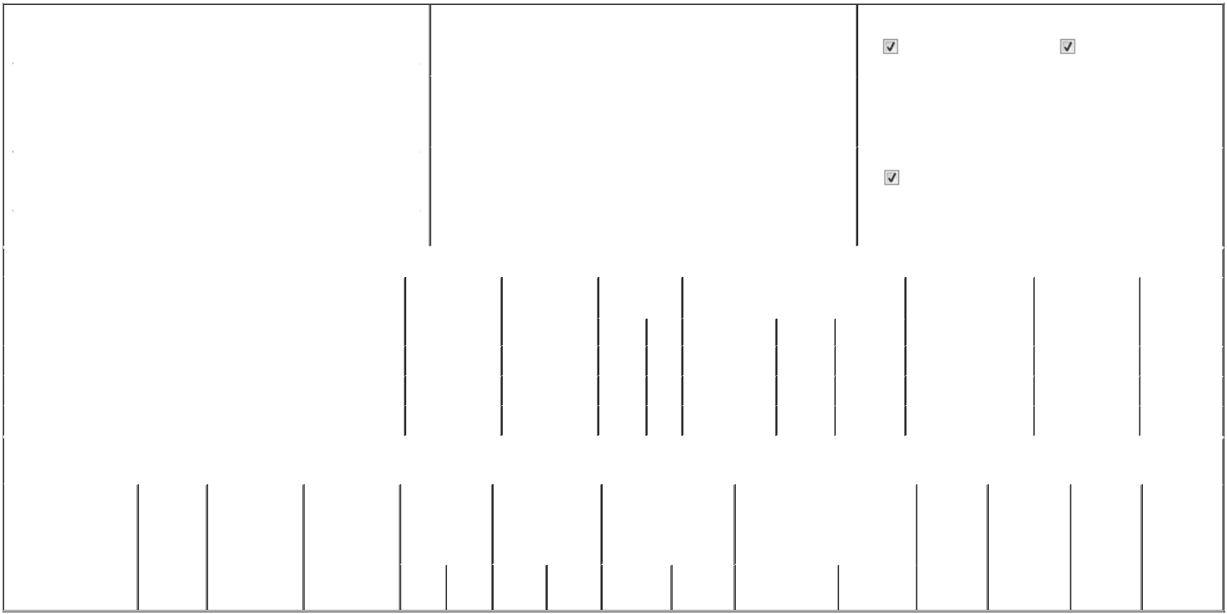

 | 1. Name and Address of Reporting Person* |  |  |  |  |  |  |  |  | 2. Issuer Name and Ticker or Trading Symbol |  |  |  |  |  |  |  |  |  | 5. Relationship of Reporting Person(s) to Issuer
 |  | Alnowaiser Turqi A. |  |  |  |  |  |  |  | Lucid Group, Inc. [ LCID ] |  |  |  |  |  |  |  |  |  | (Check all applicable)
 |  |  |  |  |  |  |  |  |  |  |  |  |  |  |  |  |  |  |  |  |  | Director |  |  | 10% Owner
 |  |  |  |  |  |  |  |  |  |  |  |  |  |  |  |  |  |  |  |  |  | Officer (give title |  |  | Other (specify below)
 |  | (Last) | (First) |  |  | (Middle) |  |  |  |  |  |  |  |  |  |  |  |  |  |  |  | below)
 |  | (Last) |  |  |  | (Middle) |  |  |  | 3. Date of Earliest Transaction (Month/Day/Year) |  |  |  |  |  |  |  |  |  |  |  | below)
 |  | C/O LUCID GROUP, INC. |  |  |  |  | 06/04/2026
 |  | 7373 GATEWAY BOULEVARD
 |  |  |  |  |  |  |  |  |  | 4. If Amendment, Date of Original Filed (Month/Day/Year) |  |  |  |  |  |  |  |  |  | 6. Individual or Joint/Group Filing (Check Applicable Line)
 | (Street)
 |  |  |  |  |  |  |  |  |  |  |  |  |  |  |  |  |  |  |  |  |  | Form filed by One Reporting Person
 |  | NEWARK | CA |  |  | 94560
 |  | NEWARK |  |  |  | 94560 |  |  |  |  |  |  |  |  |  |  |  |  |  |  |  | Form filed by More than One Reporting Person
 |  | (City) | (State) |  |  | (Zip)
 |  |  |  |  |  | Table I - Non-Derivative Securities Acquired, Disposed of, or Beneficially Owned
 | 1. Title of Security (Instr. 3) |  |  |  |  |  | 2. Transaction |  |  |  | 2A. Deemed |  |  | 3. Transaction |  | 4. Securities Acquired (A) or Disposed Of |  |  |  |  | 5. Amount of Securities |  |  | 6. Ownership |  | 7. Nature of
 |  |  |  |  |  |  | Date |  |  |  | Execution Date, |  |  | Code (Instr. 8) |  | (D) (Instr. 3, 4 and 5) |  |  |  |  | Beneficially Owned |  |  | Form: Direct (D) or |  | Indirect
 |  |  |  |  |  |  | (Month/Day/Year) |  |  |  | if any |  |  |  |  |  |  |  |  |  | Following Reported |  |  | Indirect (I) (Instr. 4) |  | Beneficial
 |  |  |  |  |  |  |  |  |  |  | (Month/Day/Year) |  |  | Code | V | Amount |  | (A) or (D) | Price |  | Transaction(s) (Instr. 3 |  |  |  |  | Ownership
 |  |  |  |  |  |  |  |  |  |  |  |  |  | Code | V | Amount |  | (A) or (D) |  |  | and 4) |  |  |  |  | (Instr. 4)
 | Class A Common Stock |  |  |  |  |  | 06/04/2026 |  |  |  |  |  |  | F |  | 1,248⁽¹⁾ |  | D | $5.72 |  | 231,182 |  |  |  | _{D}(2)
 | Class A Common Stock |  |  |  |  |  | 06/04/2026 |  |  |  |  |  |  | A |  | 43,870⁽³⁾ |  | A | _{$0}(4) |  | 275,052 |  |  |  | _{D}(2)
 | Class A Common Stock |  |  |  |  |  | 06/04/2026 |  |  |  |  |  |  | A |  | 1,299⁽⁵⁾ |  | A | _{$0}(4) |  | 276,351 |  |  |  | _{D}(2)
 |  |  |  |  |  | Table II - Derivative Securities Acquired, Disposed of, or Beneficially Owned
 |  |  |  |  |  |  | (e.g., puts, calls, warrants, options, convertible securities)
 | 1. Title of Derivative |  | 2. |  | 3. Transaction | 3A. Deemed | 4. Transaction |  |  |  | 5. Number of |  |  | 6. Date Exercisable and |  |  | 7. Title and Amount of Securities |  |  |  |  | 8. Price of | 9. Number of |  | 10. | 11. Nature of
 | Security (Instr. 3) |  | Conversion |  | Date | Execution Date, | Code (Instr. 8) |  |  |  | Derivative |  |  | Expiration Date |  |  | Underlying Derivative Security |  |  |  |  | Derivative | derivative |  | Ownership | Indirect
 |  |  | or Exercise |  | (Month/Day/Year) if any |  |  |  |  |  | Securities Acquired |  |  | (Month/Day/Year) |  |  | (Instr. 3 and 4) |  |  |  |  | Security | Securities |  | Form: | Beneficial
 |  |  | Price of |  |  | (Month/Day/Year) |  |  |  |  | (A) or Disposed of |  |  |  |  |  |  |  |  |  |  | (Instr. 5) | Beneficially |  | Direct (D) or | Ownership
 |  |  | Derivative |  |  |  |  |  |  |  | (D) (Instr. 3, 4 and |  |  |  |  |  |  |  |  |  |  |  | Owned |  | Indirect (I) | (Instr. 4)
 |  |  | Security |  |  |  |  |  |  |  | 5) |  |  |  |  |  |  |  |  |  |  |  | Following |  | (Instr. 4)
 |  |  |  |  |  |  |  |  |  |  |  |  |  |  |  |  |  |  |  |  |  |  | Reported
 |  |  |  |  |  |  |  |  |  |  |  |  |  |  |  |  |  |  | Amount or |  |  |  | Transaction(s)
 |  |  |  |  |  |  |  |  |  |  |  |  |  | Date |  | Expiration |  |  | Number of |  |  |  | (Instr. 4)
 |  |  |  |  |  |  | Code V |  |  |  | (A) | (D) |  | Exercisable |  | Date | Title |  | Shares

Explanation of Responses:

- Represents shares that have been withheld by the Issuer to satisfy tax withholding and remittance obligations in connection with the time-based vesting of restricted stock units previously reported on Form 4s filed by the reporting person.

- The reporting person is deemed a beneficial owner of 10% of the issued and outstanding shares of Class A Common Stock of the Issuer because the reporting person has voting power over 280,188,185 shares of Class A Common Stock (the "Ayar Shares") beneficially owned by Ayar Third Investment Company ("Ayar"), a wholly-owned subsidiary of The Public Investment Fund ("PIF"), pursuant to authority delegated to him as a co-manager of Ayar, as reported on the Schedule 13D/A filed with the Securities and Exchange Commission on April 30, 2026, by the PIF. The reporting person does not have, and disclaims, any pecuniary interest in such Ayar Shares.

- These restricted stock units ("RSUs") will vest in full on the earlier of (i) the one-year anniversary of the date of grant or (ii) the date of the next annual meeting of stockholders held after the date of grant, in each case, subject to the reporting person's continued service on the board of directors through the applicable vesting date.

- RSUs are settled in shares of Class A Common Stock on a one-for-one basis.

- These RSUs vest in full on the date of the grant in connection with past service.

Remarks:

/s/ Bruce Wang, as attorney-in-fact for

Turqi A. Alnowaiser

** Signature of Reporting Person

06/08/2026

Date

Reminder: Report on a separate line for each class of securities beneficially owned directly or indirectly.

* If the form is filed by more than one reporting person, see Instruction 4 (b)(v).

- Intentional misstatements or omissions of facts constitute Federal Criminal Violations See 18 U.S.C. 1001 and 15 U.S.C. 78ff(a). Note: File three copies of this Form, one of which must be manually signed. If space is insufficient, see Instruction 6 for procedure.
Persons who respond to the collection of information contained in this form are not required to respond unless the form displays a currently valid OMB Number.



