SEC Form 4
FORM 4 |  | UNITED STATES SECURITIES AND EXCHANGE COMMISSION  Washington, D.C. 20549  STATEMENT OF CHANGES IN BENEFICIAL OWNERSHIP  Filed pursuant to Section 16(a) of the Securities Exchange Act of 1934  or Section 30(h) of the Investment Company Act of 1940
  OMB APPROVAL
  OMB Number: | 3235-0287
  Estimated average burden
  hours per response: | 0.5
 | Check this box if no longer subject to Section 16. Form 4 or Form 5 obligations may continue. See Instruction 1(b).
 | Check this box to indicate that a transaction was made pursuant to a contract, instruction or written plan for the purchase or sale of equity securities of the issuer that is intended to satisfy the affirmative defense conditions of Rule 10b5-1(c). See Instruction 10.
1. Name and Address of Reporting Person*  (Street) | 2. Issuer Name and Ticker or Trading Symbol  Lucid Group, Inc. [ LCID ] | 5. Relationship of Reporting Person(s) to Issuer  (Check all applicable)
  Maynard-Elliott Nichelle
  (Last) | (First) | (Middle)
  C/O LUCID GROUP, INC.
  7373 GATEWAY BOULEVARD
  NEWARK | CA | 94560
  (City) | (State) | (Zip)
   | Director |  | 10% Owner
   | Officer (give title below) |  | Other (specify below)
3. Date of Earliest Transaction (Month/Day/Year)
06/04/2026
 | 4. If Amendment, Date of Original Filed (Month/Day/Year) | 6. Individual or Joint/Group Filing (Check Applicable Line)
  Form filed by One Reporting Person
  Form filed by More than One Reporting Person
Table I - Non-Derivative Securities Acquired, Disposed of, or Beneficially Owned
1. Title of Security (Instr. 3) | 2. Transaction Date (Month/Day/Year) | 2A. Deemed Execution Date, if any (Month/Day/Year) | 3. Transaction Code (Instr. 8) |  | 4. Securities Acquired (A) or Disposed Of (D) (Instr. 3, 4 and 5) |  |  | 5. Amount of Securities Beneficially Owned Following Reported Transaction(s) (Instr. 3 and 4) | 6. Ownership Form: Direct (D) or Indirect (I) (Instr. 4) | 7. Nature of Indirect Beneficial Ownership (Instr. 4)
1. Title of Security (Instr. 3) | 2. Transaction Date (Month/Day/Year) | 2A. Deemed Execution Date, if any (Month/Day/Year) | Code | V | Amount | (A) or (D) | Price |  | 6. Ownership Form: Direct (D) or Indirect (I) (Instr. 4) | 7. Nature of Indirect Beneficial Ownership (Instr. 4)
Class A Common Stock | 06/04/2026 |  | A |  | 43,870(1) | A | $0(2) | 69,754 | D
Table II - Derivative Securities Acquired, Disposed of, or Beneficially Owned
(e.g., puts, calls, warrants, options, convertible securities)
1. Title of Derivative Security (Instr. 3) | 2. Conversion or Exercise Price of Derivative Security | 3. Transaction Date (Month/Day/Year) | 3A. Deemed Execution Date, if any (Month/Day/Year) | 4. Transaction Code (Instr. 8) |  | 5. Number of Derivative Securities Acquired (A) or Disposed of (D) (Instr. 3, 4 and 5) |  | 6. Date Exercisable and Expiration Date (Month/Day/Year) |  | 7. Title and Amount of Securities Underlying Derivative Security (Instr. 3 and 4) |  | 8. Price of Derivative Security (Instr. 5) | 9. Number of derivative Securities Beneficially Owned Following Reported Transaction(s) (Instr. 4) | 10. Ownership Form: Direct (D) or Indirect (I) (Instr. 4) | 11. Nature of Indirect Beneficial Ownership (Instr. 4)
 |  |  |  | Code | V | (A) | (D) | Date Exercisable | Expiration Date | Title | Amount or Number of Shares
Explanation of Responses:
1. These restricted stock units ("RSUs") will vest in full on the earlier of (i) the one-year anniversary of the date of grant or (ii) the date of the next annual meeting of stockholders held after the date of grant, in each case, subject to the reporting person's continued service on the board of directors through the applicable vesting date. The RSUs are also subject to a deferral election by the reporting person and shares will not be issued until the designated deferred settlement date.
2. RSUs are settled in shares of Class A Common Stock on a one-for-one basis.
Remarks:
 | /s/ Bruce Wang, as attorney-in-fact for Nichelle Maynard-Elliott | 06/08/2026
 | ** Signature of Reporting Person | Date
Reminder: Report on a separate line for each class of securities beneficially owned directly or indirectly.
* If the form is filed by more than one reporting person, see Instruction 4 (b)(v).
** Intentional misstatements or omissions of facts constitute Federal Criminal Violations See 18 U.S.C. 1001 and 15 U.S.C. 78ff(a).
Note: File three copies of this Form, one of which must be manually signed. If space is insufficient, see Instruction 6 for procedure.
Persons who respond to the collection of information contained in this form are not required to respond unless the form displays a currently valid OMB Number.
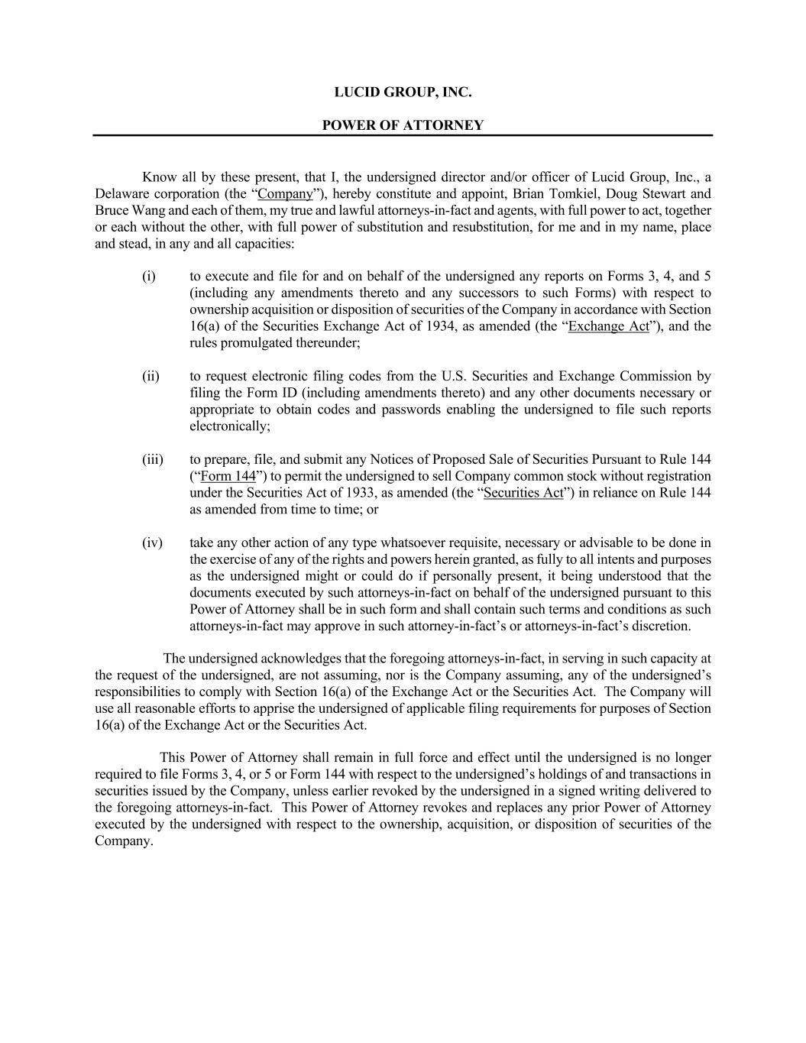
LUCID GROUP, INC. POWER OF ATTORNEY Know all by these present, that I, the undersigned director and/or officer of Lucid Group, Inc., a Delaware corporation (the “Company”), hereby constitute and appoint, Brian Tomkiel, Doug Stewart and Bruce Wang and each of them, my true and lawful attorneys-in-fact and agents, with full power to act, together or each without the other, with full power of substitution and resubstitution, for me and in my name, place and stead, in any and all capacities: (i) to execute and file for and on behalf of the undersigned any reports on Forms 3, 4, and 5 (including any amendments thereto and any successors to such Forms) with respect to ownership acquisition or disposition of securities of the Company in accordance with Section 16(a) of the Securities Exchange Act of 1934, as amended (the “Exchange Act”), and the rules promulgated thereunder; (ii) to request electronic filing codes from the U.S. Securities and Exchange Commission by filing the Form ID (including amendments thereto) and any other documents necessary or appropriate to obtain codes and passwords enabling the undersigned to file such reports electronically; (iii) to prepare, file, and submit any Notices of Proposed Sale of Securities Pursuant to Rule 144 (“Form 144”) to permit the undersigned to sell Company common stock without registration under the Securities Act of 1933, as amended (the “Securities Act”) in reliance on Rule 144 as amended from time to time; or (iv) take any other action of any type whatsoever requisite, necessary or advisable to be done in the exercise of any of the rights and powers herein granted, as fully to all intents and purposes as the undersigned might or could do if personally present, it being understood that the documents executed by such attorneys-in-fact on behalf of the undersigned pursuant to this Power of Attorney shall be in such form and shall contain such terms and conditions as such attorneys-in-fact may approve in such attorney-in-fact’s or attorneys-in-fact’s discretion. The undersigned acknowledges that the foregoing attorneys-in-fact, in serving in such capacity at the request of the undersigned, are not assuming, nor is the Company assuming, any of the undersigned’s responsibilities to comply with Section 16(a) of the Exchange Act or the Securities Act. The Company will use all reasonable efforts to apprise the undersigned of applicable filing requirements for purposes of Section 16(a) of the Exchange Act or the Securities Act. This Power of Attorney shall remain in full force and effect until the undersigned is no longer required to file Forms 3, 4, or 5 or Form 144 with respect to the undersigned’s holdings of and transactions in securities issued by the Company, unless earlier revoked by the undersigned in a signed writing delivered to the foregoing attorneys-in-fact. This Power of Attorney revokes and replaces any prior Power of Attorney executed by the undersigned with respect to the ownership, acquisition, or disposition of securities of the Company.

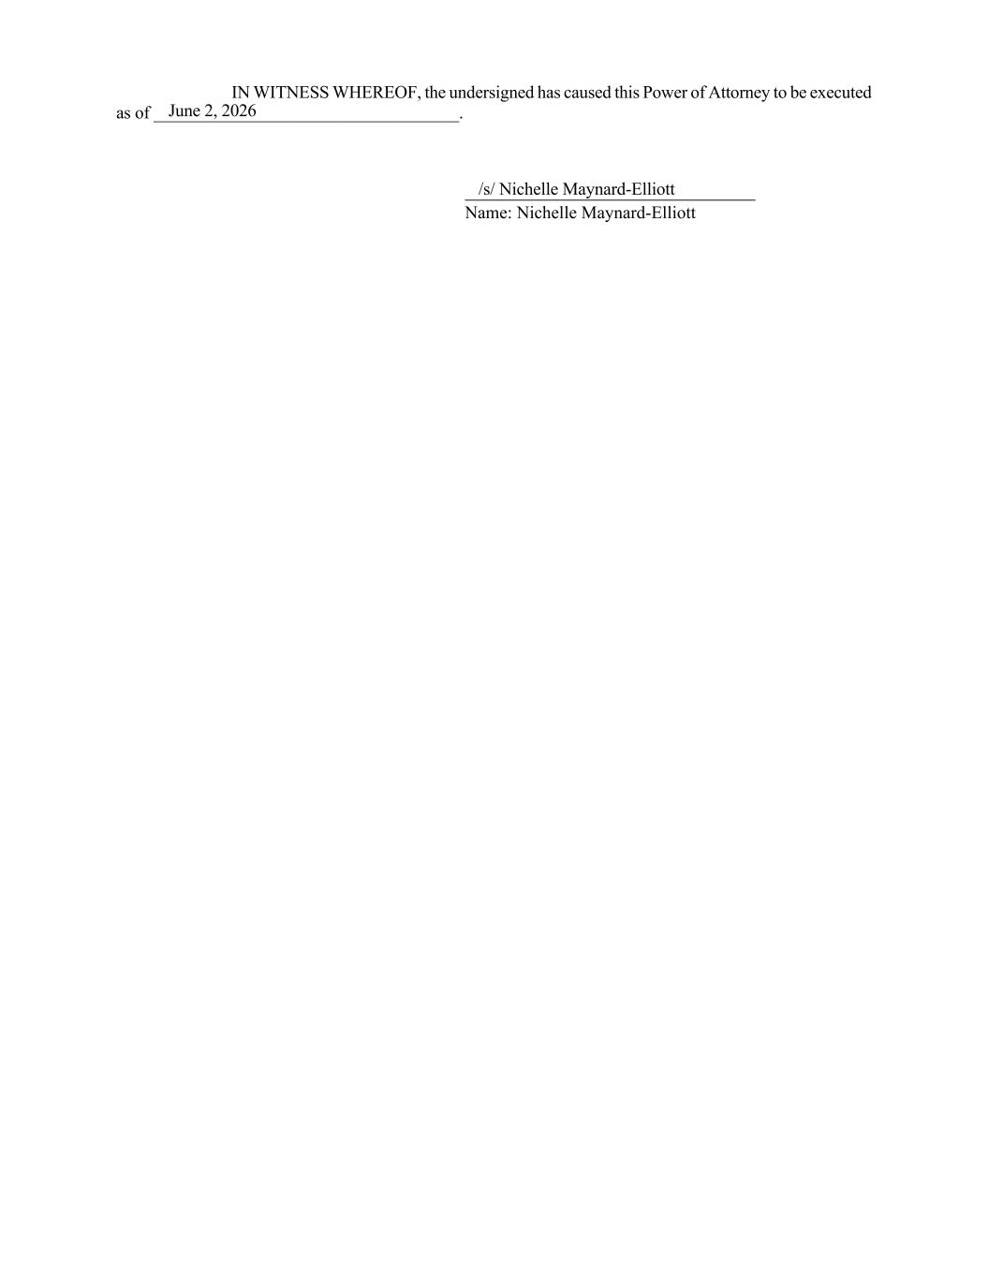
IN WITNESS WHEREOF, the undersigned has caused this Power of Attorney to be executed as of ___________________________________. Name: Nichelle Maynard-Elliott June 2, 2026 /s/ Nichelle Maynard-Elliott

